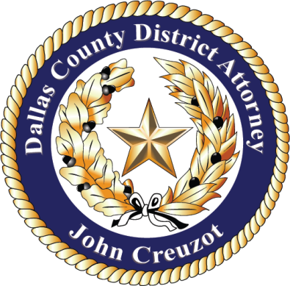

March 4, 2021 Contact: Tasha Tsiaperas
Dallas County District Attorney’s Office
214-653-3756 (Office)
Tasha.Tsiaperas@DallasCounty.org

Statement on the arrest of Bryan Riser

The Dallas County District Attorney’s Office conducts its own independent investigation when criminal cases are filed. The office will thoroughly review the case file on Bryan Riser after the Dallas Police Department provides it. It is the policy of this office not to comment on cases that are under investigation prior to a grand jury hearing.

