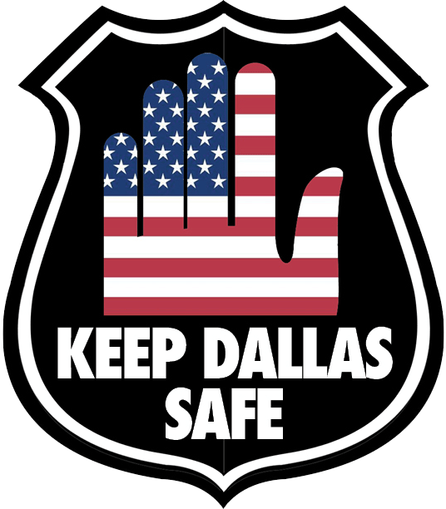Keep Dallas Safe Official statement to Paula Blackmon’s opinion piece, Dallas Morning News 10/11/2020
While Keep Dallas Safe appreciates the sentiment outlined in Blackmon’s piece from 10/22/2020- one scorning ‘partisan politics’ and describing how ‘difficult’ the decision to slash 7 million dollars from the police overtime budget was- the fact remains that Blackmon and 10 of her fellow council members consciously chose to remove needed funds at a time of crisis and violence.
Continually, city leaders across America feel this is a good time to experiment with police department funding, trying unproven tactics with taxpayer money and attaching themselves to political rhetoric they feel will land them a win in the next election. Dallas is no exception.
Blackmon, in her opinion piece, describes a city council that “will find our way forward only if we communicate and learn to treat each other with respect”. This is a clear indication of the disfunction that is rampant in the Dallas City Council, and public appeals for decorum behind closed doors will not solve the issue of public safety.
Keep Dallas Safe anxiously awaits the “practical solutions for many of the concerns we (the council) heard throughout budget townhalls and community meetings.” We are awaiting how the council plans to “create achievable goals and deliver real results to our residents.” That is what KDS has been asking for. This sounds like the rest of the statements the majority of the council continue to issue: style with no substance.
What Keep Dallas Safe is asking, is for the council to provide a specific plan to address the violence and vandalism they have allowed to occur. However, they would rather capitulate to popular politics than keep Dallas residents safe. We will continue to push the city to issue a plan for potential unrest in November; failing to do so will result in a change of leadership in May. That is why Keep Dallas was formed, and that is why we are having our next rally, Saturday, October 24th, 11am at Dallas City Hall.

Amy Gibson
Official Spokesperson
Keep Dallas Safe
www.keepdallassafe.org
amy@keepdallassafe.org

