Equity: Together We Can Achieve It! Workshop

  - Facilitator Handbook
  - Center for Elimination of Disproportionality and Disparities

  - March 2018

Table of Contents
Introduction 5
Acknowledgements 5
Why this Workshop? 6
Facilitation Tips 7
About this Handbook 11
Equity: Together We Can Achieve It! Agenda 13
Module 1: Welcome and Introduction 15
Module Overview 15
Discussion 17
Module 2: Definitions 24
Module Overview 24
Discussion 25
Module 3: Understanding Our History 34
Module Overview 34
Discussion 36
Module 4: Understanding Race Equity Principles 45
Module Overview 45
Discussion 47
Scenarios Key 54
Module 5: Data Driven Strategies 63
Module Overview 63
Discussion 65
Module 6: Collaboration and Engagement with Communities and Across Systems 73
Module Overview 73
Discussion 75
Module 7: Closing and Wrap-up 83
Module Overview 83
Discussion 84
Appendix A. Facilitator Handbook References 1
Appendix B. Module 3. Timeline of Historical Events 3
Appendix C. Module 3. Timeline References 30
Appendix D. Curriculum Materials for Reproduction 35
Appendix E. Curriculum PowerPoint 36
Appendix F. The Texas Model: A Framework for Equity 41

Introduction

Acknowledgements
The Center for Elimination of Disproportionality and Disparities (Center) extends its deepest thanks and appreciation to the following individuals and organizations that supported the development of this curriculum.
- All pilot participants across Texas: Thank you for your time, comments, and inspiration! Pilots were held in Abilene, Austin, El Paso, Houston, Irving, McAllen, and Tyler.
- Casey Family Programs
- The Curriculum Workgroup - Dr. Amanda Banks, Melonee Carter, Sheila Craig, Virginia Flores, Carl Gonzales, Dr. Ebony Hall, Pastor Ray Hendricks, Maxine Jones-Robinson, Rebecca Kerst, Stephanie Lehr, Courtney McElhaney-Peebles, Damaris Nicholson, Jon Olson, Carolyne Rodriguez, Shondra Rogers, Tanya Rollins
- Directors at the Center: Dr. Rosanna Barrett, Dr. Herman Horn, and Mr. David Luna
- Equity Specialists supporting training pilots: Daphne Casses, Sheila Dismuke-Williams, Sharon Owens, Erika Jackson-Ramos, Roxane May, Mari Tucker, Mia Williams
- Executive Commissioner Kyle Janek and Deputy Executive Commissioner Rolando Garza
- Texas Department of Family and Protective Services
- Health and Human Services employees across Texas that contributed scenarios for Module Four.
- The People's Institute for Survival and Beyond

Why this Workshop?
This Facilitator's Handbook is the result of efforts from many of the individuals listed above. The Center for Elimination of Disproportionality and Disparities embarked on a journey to create a meaningful, impactful, and effective curriculum to support improved outcomes for all people that access public health and human services in Texas. The curriculum is designed to be relevant to any professional, provider, consumer, client, community member, and any other interested party.
Racial and ethnic disproportionality and disparities impact virtually every public system in virtually every community of the country. Different systems often have different labels to describe the phenomenon. Some of these include: achievement gap; disproportionality; Disproportionate Minority Contact; health disparity; disparity; and Historically Underutilized Business. The differences in language point to a common, disturbing, and unacceptable pattern: namely, that people of color, most often African Americans, American Indians, and Hispanics, experience a level of service delivery and outcomes that is less than that of their White peers.
The Center for Elimination of Disproportionality and Disparities, as an office within the Texas Health and Human Services Commission, believes that some of the responsibility for these disparate outcomes belongs to the agencies and systems that provide services. This curriculum is designed to provide a common language for discussing issues of race and ethnicity; explore elements of our society's history that contribute to modern inequitable outcomes; and review principles that can support work to reform our agencies and systems to provide optimal services to all and encourage healthier Texans and communities.

Facilitation Tips
This workshop requires facilitation skills and abilities as opposed to trainer skills and abilities. Awareness of the style and delivery differences between a trainer and a facilitator is a critical factor in effectively and successfully delivering this curriculum in a way that is safe, meaningful, and effective for participants.
Facilitation focuses on helping individuals process and become aware of information which may or may not be new. Facilitation assists individuals to take the information they have learned and adapt it to the work that they do. Facilitation assists individuals to share different ideas, viewpoints, perspectives, and experiences with other individual participants. Frequently, facilitators may not have the extent of experience in the subject matter that the participants have.
Important elements of a strong facilitator of this curriculum include:
- The facilitator solicits experiences and discussion from the participants to highlight concepts.
- The facilitator frequently asks more questions of the participants, encouraging them to develop critical thinking skills and acknowledge their experiences.
- Participants frequently talk more than the facilitator (Dahlin, 2009)
Specific points of consideration for facilitators:
- 24 is the maximum number of classroom participants.
- 10 is the minimum number of classroom participants.
- Racial diversity is important for the larger group and becomes a critical factor during small group activities.
- The opening act of welcoming participants to the classroom sets the tempo for the entire workshop. The hallmark for the welcome should be one of high energy and enthusiasm.
- Preparation is critical. Know the curriculum well enough to deliver it using your own words and style and be certain to familiarize yourself with the entire curriculum, not just the sections you will deliver.

Additional tips for being an effective facilitator include:
- Co-facilitation means that you and your co-facilitator are jointly responsible for the effectiveness and the success of the workshop. The point is not how well you deliver your assigned sections, but how well you partner with one another to deliver the best classroom experience possible.
- Be thoughtful in grouping participants. Look at factors such as personalities, gender, race and ethnicity, the participants' familiarity with one another, and how participants have been interacting throughout the day. You want to stretch your participants beyond their usual boundaries.
- Be flexible but firm on groups reporting out. Reporting out need not be stressful. Remind the groups that reporting out is a way of sharing knowledge and information and the manner in which it is done is secondary. Reporting out may be a joint effort or one individual can represent the group.
- You do not need to be the expert on all matters contained in the curriculum. Use the "boomerang" tactic freely and frequently. When asked a question, say "Great question! What do you think about that question?" Or, "Great question! Who would like to address that question?" Any means of deflecting the question back to the class is appropriate and thought-provoking for the participants.
- When resistance or inappropriate remarks occur, address them. Address them in a neutral, natural manner. Work with your co-facilitator beforehand to strategize how you will address resistance and inappropriateness jointly whenever possible. Most importantly, do not fail to address any inappropriate remarks or resistance solely because the remarks were made during a section that was being covered by your co-facilitator. The class is a joint responsibility from beginning to end and the management of the class is far easier when you work in collaboration with your co-facilitator.
- Enjoy the process of facilitating this curriculum! The process will result in stretching and educating you.

Room Setup
The ideal room arrangement for this workshop involves participants seated at tables touching each other, shaped in a large U, with the opening facing the front of the room. The room should include a small table and chairs for the facilitators near the projection screen and laptop used for controlling the PowerPoint. Facilitators and participants should have ample space to move, get into groups, and get up to post chart paper on the walls.
Posters and chart paper completed during activities should be posted around the room at eye level. This creates a "360° training environment," allowing participants to see their work grow and change throughout the day. The Race Equity Principles posters should be covered at the start of the day as described in Module Four.
Despite your best efforts at locating an appropriate training room, you may find yourself facilitating in less than ideal conditions. It is imperative that participants (and facilitators) feel comfortable, as you will all be working diligently throughout the day. If you cannot create a U-shape based on the room layout, consider grouping tables into small pods. While some participants will have to turn their seats to look at facilitators, this is considered better than cramming people too close together. Use your best judgment and think about what would make you, as a participant, feel most comfortable.

Materials Overview
This training requires that facilitators have a laptop and projector available to display a PowerPoint presentation. If the technology is unavailable to you, you can still facilitate the curriculum; however, you may want to consider printing copies of the presentation for your participants.
The Equity in Health and Human Services Facilitator Kit contains the following materials:
- Facilitator Handbook;
- Participant Handbook for duplication;
- Posters:
- Agenda Overview;
- Group Agreements;
- Goals and Objectives;
- Race Equity Principles (3);
- Collaboration and Engagement Principles;
- Module 3:
- Historical event cards;
- Timeline cards;
- System cards;
- Module 4: Race Equity scenario strips; and
- Module 6: Collaboration and Engagement scenario strips.
This workshop also requires some other basic materials, in addition to those provided in the Equity: Together We Can Achieve It! Facilitator Kit. These materials are regularly available through office supply stores:
- Cardstock for name tents;
- Chart paper;
- Chart markers; and
- Masking tape.

About this Handbook
This Facilitator Handbook should serve as your guide to facilitating the Equity: Together We Can Achieve It! workshop. You will find that it reads like a script; that is, you could stand at the front of the room and read directly from this Handbook. However, as indicated in the Facilitation Tips section above, that style is not nearly as effective and engaging as a true facilitation model.
With those things in mind, consider the Handbook as a blueprint rather than a verbatim script. We have included specific language addressing key points, but you should not feel restricted to reading the contents of this Handbook. Effective facilitators use their own words and experiences, in concert with the voices and views of their participants, to create a unique and meaningful learning experience. Each time you facilitate this curriculum will be different, and we believe that each facilitation will further you on your own journey of race equity.
This Handbook is divided into several major sections. The Introduction includes general information about the workshop and this manual. Each Module is presented in detail, with scripts to support you as you become more comfortable facilitating the curriculum. Finally, several Appendices include References, the PowerPoint, the Texas Model: A Framework for Equity, and some templates of curriculum materials for reference and reproduction.
Three goals of the Equity: Together We Can Achieve It! curriculum are:
- Increase awareness of racial and ethnic disparities in outcomes within our agencies.
- Educate staff about ways they can seek equity in their practice.
- Further develop cultural competencies of staff and stakeholders in Health and Human Services (HHS) agencies and other systems and communities.
Three Learning Objectives of the curriculum are:
- Participants will identify and recognize the existence of systemic racial inequities within health and human services.
- Participants will examine how they play a role in perpetuating practices that lead to inequitable outcomes within systems.
- Participants will identify strategies to address the causes of systemic racial inequities.
There are Facilitation Tips spread throughout each module. These tips offer guidance about specific points in the curriculum beyond the script. They may offer additional insight you can share with participants if warranted, prepare you for potentially challenging moments, or provide suggestions about how to tweak content to save time if needed.
Finally, we hope you have fun facilitating this workshop! Race Equity work is challenging and rewarding, and that is how we believe facilitating this workshop will be for you. All the best as you continue your journey!

Equity: Together We Can Achieve It! Agenda
Table 1.1 Sample Training Agenda
Time | Who | Activity | Materials
8:30 -  9:00 am |  | Module 1: Welcome and Introduction (30 min.)  Discussion, Part One: Welcome and Background  Discussion, Part Two: Objectives, Logistics, Agenda, Group Agreements | - Posters: Agenda, Group Agreements, Course Objectives, and Texas Model  - Participant Handbook  - Pre-tests  - Name tent cards  - PowerPoint
9:00 -10:00 am |  | Module 2: Definitions  Discussion, Part One: A Few Basic Definitions (40 min)  Activity One: Reflecting on the Definitions (20 min.) | - Chart paper  - Markers  - Participant Handbook  - PowerPoint
10:00 - 10:15 am |  | Break
10:15 -  11:20 am |  | Module 3: Understanding Our History  Activity One: Thinking Critically About History (25 min.)  Activity Two: The Impact of History on Systems Today (40 min) | - Cards: Timeline, Historical Events, and System  - Chart paper  - Markers  - Masking tape  - PowerPoint
11:20 - 12:30 pm |  | Lunch
12:30 -  1:55 pm |  | Module 4: Race Equity Principles  Activity One: Defining Race Equity Principles (30 min.)  Activity Two: Understanding Race Equity Principles (30 min.)  Activity Three: Application (35 min.) | - Participant Handbook  - Posters: 7 terms and Principles  - Chart paper  - Scenario Strips  - PowerPoint
1:55 - 2:10 pm |  | Break
2:10 -  3:05 pm |  | Module 5: Data Driven Strategies  Parts One and Two (30 min.)  Activity One: Identifying Decision Points within a System (25 min.) | - PowerPoint  - Chart paper  - Markers
3:05 -  4:15 pm |  | Module 6: Collaboration and Engagement with Communities and Across Systems  Activity One: Understanding Collaboration and Engagement Principles (35 min.)  Activity Two: Applying the Collaboration and Engagement Principles (35 min.) | - Easel  - Chart paper  - Markers  - Poster: Collaboration and Engagement Principles  - PowerPoint
4:15 -  4:30 pm |  | Module 7: Closing and Wrap-Up (15 min.) | - Post-tests  - Certificates of Completion  - CEU request form  - Evaluations

Module 1: Welcome and Introduction

Module Overview
Facilitator Name(s): ___________________________________________________
Length of Module: 30 Minutes
Logistics: All participants together in one room
Materials:
- Participant Handbooks
- Course Objectives page in Participant Handbook
- Agenda page in Participant Handbook
- Group Agreements poster
- Markers
- Sign-in sheets
Preparation:
The room should be completely set up before participants arrive. If possible, facilitators may want to arrange the room the evening before the training begins. Sign in sheets and pre-tests should be located on a table near the entrance to the training room. See the Introduction section of this handbook on p. 3 for more detail.

Module Goals and Objectives
- Welcome participants.
- Establish a safe space for discussions.
- Introduce the Texas Model: A Framework for Equity.
- Identify components of the Texas Model: A Framework for Equity.

Facilitator Overview
- Have participants sign in to training.
- Welcome participants to the training and review logistics.
- Review training agenda, objectives, and group agreements.
- Define race, ethnicity, disproportionality, disparity, equity, and race equity lens.
Facilitation Tips
As participants enter the room, have them complete sign-in sheets. It is very important that facilitators set an open, transparent, and welcoming tone during this module. Some participants will come to the training prepared for a negative or painful experience, and facilitators should take extra care to mitigate these feelings early to the fullest extent possible.

Discussion

Introductory Remarks
Provide a welcome and greeting to participants in your own words, as an employee of a system and/or a member of a community. Include your name and agency. Explain your role as a facilitator (as opposed to a lecturer or trainer), and emphasize that participation is expected from all

Part One: Welcome and Background (10 min.)
ACTION | DIALOGUE
Say: | Now that you know who we are, we would like to learn who you are! We will go around the room and have all of you to introduce yourselves. Then we will discuss this training and why we believe it is important for all Health and Human Services staff, as well as our agency and community partners, to attend. We will discuss the objectives for this workshop, logistics for our time together today, review the agenda, and offer up definitions for a few key terms.
Say: | Let’s start on this side of the room. Please tell us your name, what agency you work for or community you represent, and what people you serve.
Say: | Thank you all for sharing! Throughout the day you will be asked to work in small groups, pairs, and all together as we learn more about disproportionality and disparities.
Say: | I am going to share some background information with you now. You may hear some terms you are unfamiliar with. We will be defining them later this morning.
Say: | Formal work to address racial disproportionality and disparities in Texas Health and Human services agencies began within Child Protective Services. In 2005, the Texas Legislature passed Senate Bill 6. This landmark legislation directed the Texas Department of Family and Protective Services, along with the Texas Health and Human Services Commission, to examine the child welfare system and identify where disproportionality may exist and, if found, to create remediation plans to address the problem. Texas was one of the first states to pass legislation addressing disproportionality. Senate Bill 6 continues to serve as a model for other states as they seek ways to impact disproportionality and disparities in their own systems.
Say: | Senate Bill 6 also required Child Protective Services to engage with the community. Disproportionality Advisory Committees were created in several communities of Texas. These alliances continue today and exist in every region of Texas.
Say: | In 2010, then Executive Commissioner Tom Suehs created the Center for Elimination of Disproportionality and Disparities. Mr. Suehs created the Center after hearing from community members and staff about the successes within Child Protective Services regarding work being done to impact disproportionality. The Center is charged with supporting the work of Health and Human Services agencies and other external organizations to achieve racial equity in decision making in outcomes and services. Our current Executive Commissioner, Mr. Charles Smith, shares this same commitment to eliminating disproportionality and disparities and improving outcomes for all those served within health and human services in Texas. This curriculum was developed and reviewed by staff at Health and Human Services state office with support from our community partners and many others.
Ask: | Before we move on, does anyone have any questions or thoughts about this training or the background information I just shared?

Facilitation Tips
Some of your participants may have arrived at this training with preconceived notions about its content or may be uncomfortable talking about sensitive topics, such as race and ethnicity. You may get some responses at this point in the training, or you may have silence, with no one offering comments. Any response is acceptable, just be prepared to deal with resistant participants or to move on to the Agenda and Objectives as needed.

Continued - Part One: Welcome and Background (10 min.)
ACTION | DIALOGUE
Say: | Many of us believe that equity is something that all Texans deserve and should expect from their public serving systems. Today we will focus on achieving racial equity. For those of us that work within systems, we must begin to examine how our roles, no matter what they are, become intertwined and interconnected with the outcomes the people that we serve experience.
Ask: | Can we agree that Texans deserve the very best from their government?
Say: | With support from the Texas Legislature, our work in Texas has evolved into something we call “the Texas Model: A Framework for Equity.” The Texas Model serves as a framework to guide our thinking and inquiry as we seek sustainable equity in our practice. You can see it in your Participant Handbook on page 6. Today we will explore a few concepts from the Texas Model in greater depth. At its core, the Texas Model encourages using data to evaluate the racial impacts of our programs and policies and to partner with other systems and communities as we seek equity in all areas of our work. It also emphasizes the importance of relationships in effective service delivery – relationships with our colleagues, managers, clients, consumers, and communities.

Part Two: Objectives, Logistics, Agenda, Group Agreements (15 min)
ACTION | DIALOGUE
Say: | Let’s review our Learning Objectives for the day. Please turn to page 4 in your Participant Handbook.
Do: | Ask for volunteers to read each of the goals and objectives. If no one volunteers, call on a participant and ask them to read an objective.
Say: | Thank you. As you can see, we will cover a lot of information today!
Say: | We will be achieving our learning objectives through five different modules today. Those modules are:  - Definitions, where we will develop a common language to guide our discussions throughout the day;  - Understanding our History, where we will review important milestones in the history of our agencies, communities, state, and country, and why they are important today;  - Understanding Race Equity Principles, where we will discuss foundational concepts of equitable practice and how they apply within our jobs and daily work activities;  - Data Driven Strategies, where we will consider the importance of examining data within our systems and communities by race and ethnicity; and finally,  - Collaboration and Engagement with Communities and Across Systems, where we will synthesize the previous modules and look at ways we can work together to help improve outcomes for all Texans that we serve.
Say: | We will take one break in the morning and one in the afternoon, and have time for a lunch break as well. We ask that everyone return on time from lunch and our breaks so we can get through all of the material. Your time is very important to us, and we do not plan to go over.
Facilitation Tips
This is a good time to address logistics related to your training location, particularly the location of restrooms.
ACTION | DIALOGUE
Say: | Today we will be having conversations about race and ethnicity, community engagement, and ensuring equity and humanity in the delivery of social services.
Ask: | By a show of hands, who has ever had a conversation about race and ethnicity where they have felt uncomfortable?
Say: | Thank you. As you can see, we will cover a lot of information today!
Say: | Look at the hands, and I bet if we talked about it long enough, we could probably find a situation where each of us has had a similar experience. I know I have! Even though each of us check a box for race, we oftentimes have a difficult time talking about race and ethnicity, particularly when we are in mixed racial company, as we are today. We believe it is important to create a safe space to have an open, honest, and constructive dialogue about issues around race and ethnicity in Texas. We have developed a set of Group Agreements to guide our time together today.  [Refer to Group Agreements Poster and Participant Handbook, page 5.]
Facilitation Tips
The pre-printed Group Agreements poster and Participants Handbook list includes the following materials: (1) Confidentiality; (2) Find Your Growing Edge; (3) Listen and Be Respectful; (4) No Racial Slurs; (5) Focus on Race/Ethnicity in the United States and Texas; (6) Stay Engaged; (7) Everyone Participates; and (8) Manage Technology.

Continued - Part Two: Objectives, Logistics, Agenda, Group Agreements (15 min)
ACTION | DIALOGUE
Do:: | Ask participants to explain each statement of the Group Agreements in their own words and share why it might be important.
Facilitation Tips
You may occasionally have a participant that generates discussion about the Group Agreements, particularly the statement, “No Racial Slurs.” If this occurs, it may be helpful to explain that for our purposes, slurs are hurtful words that derogatorily refer to people’s race and ethnicity. While some people may choose to use them in their personal lives, they are inappropriate, at best, for a professional environment.
ACTION | DIALOGUE
Say: | Our experiences conducting this training and others like it have shown us that these agreements are critical to allowing us to move forward constructively. They will guide our discussion throughout the day.
Ask: | Would anyone like to add additional statements to our Group Agreements?
Facilitation Tips
The co-facilitator for the workshop should have a piece of blank chart paper, a marker, and tape ready to go. Add additional suggestions, if any, for the Group Agreements to the chart paper and affix it to the wall below the printed Group Agreements poster.
ACTION | DIALOGUE
Say: | We ask that you show your willingness to follow these agreements by raising your hand. Please raise your hand if you commit to abiding by these agreements for our training today.

Facilitation Tips
You could experience the unlikely event that a participant refuses to agree to abide by the Group Agreements. If so, you can politely ask the participant to state why they did not raise their hand. Try discussing their issue quickly with the larger group and see if you can find resolution. Explain that the process cannot move forward unless every participant is willing to abide by the Group Agreements to help ensure a safe space for all participants. If the participant still refuses to comply, the co-facilitator should ask them to step outside the training room and explain that this individual will not be permitted to participate in the training.
ACTION | DIALOGUE
Ask: | Why are these Group Agreements important to our discussion today?
Say: | Thank you for starting out the day with us! Before we can have meaningful discussions about these important issues, we need to have a common understanding of basic definitions. Now we are going to move into our definitions module, then look at how history plays a role in our systems and communities today.

Module 2: Definitions

Module Overview
Facilitators: ___________________________________________________
Time: 1 Hour
Logistics: All participants together in one room
Materials:
- Participant Handbooks
- Curriculum PowerPoint
Preparation: The curriculum PowerPoint should be in focus and on the “Module 2 – Definitions” slide. Your co-facilitator should be prepared to move the PowerPoint to show four additional slides during this module. You should also be prepared to divide the class into small groups for the discussion part of this module.

Module Goals and Objectives
Goal: Develop a common language for talking about racial equity.
Objectives:
- Define key terms.
- Use a common language to support communication, sharing, and collaboration, and for talking effectively about issues of race and ethnicity and how they impact communities.

Facilitator Overview
- Define disproportionality, disparity, equality, equity, race, ethnicity, and race equity lens.
- Have participants get into small groups to discuss these terms.
- Debrief that discussion with the entire class.

Discussion

Introductory Remarks
ACTION | DIALOGUE
Say: | Before we move on to our third module of the day, we need to discuss some basic definitions. First, let’s review our Learning Objectives for this module. Please turn to page 7 in your Participant Handbook.
Do: | Ask for volunteers to read each of the goals and objectives. If no one volunteers, call on a participant and ask them to read an objective.
Say: | Thank you. You may not agree with these definitions, but for purposes of our learning together today, they will guide our discussions. Although you can find other definitions online, these are supported in academic research and have been the foundation of our work in Texas for over a decade. You can follow along on page 8 of your Participant Manual.

Part One: A Few Basic Definitions (30 minutes)
ACTION | DIALOGUE
Say: | The first term is “disproportionality.” We define disproportionality as “the under or overrepresentation of a particular group, race, or ethnicity in a public system compared to their representation in the general population” (APHSA, 2010).
Say: | That is a big word for a fairly simple concept. For example, according to the federal Health Resources and Services Administration, women nurses far outnumber men. 91% of nurses are women, while about 9% of nurses are men (HRSA, 2013). So, we could say that women are disproportionately overrepresented as nurses.
Say: | Graphs can be very useful for understanding disproportionality. Here is a representation of the nurse data I just mentioned.
Do: | Pull up the second slide of Module 2, “Nurses by Gender, 2010.”
Say: | As you can see, many more women are nurses as compared to their proportion in the general adult population. [Pause] Now let’s look at criminal justice statistics in Texas for evidence of disproportionality. These are from the Texas Department of Criminal Justice, or TDCJ (TDCJ, 2013).
Do: | Pull up the third slide of Module 2, “State of Texas Criminal Justice – FY 2012.”
Say: | “Receives” represents all of the people that became incarcerated by TDCJ during fiscal year 2012. “On Hand” represents all of the inmates in TDCJ’s custody at the end of the year. “Releases” represents all of the people that were released from TDCJ custody during fiscal year 2012.
Ask: | Does anyone see disproportionality in this slide? Who is disproportionately overrepresented? Are any groups disproportionately underrepresented?
Say: | Please note that these are simply numbers from the Office of the State Demographer and the Texas Department of Criminal Justice. The data do not show us who should be arrested, or why this disproportionality exists. At this point we are only describing the phenomenon.
Ask: | Does anyone have any questions before we move on?
Facilitation Tips
This slide could generate some energetic discussion among your participants. At this point in the workshop, try to guide the discussion to help people’s understanding of the definition of disproportionality. If some participants want to push deeper into reasons why disproportionality exists in the criminal justice system, consider offering that everyone will have the opportunity to look at historical factors contributing to this and other outcomes in the next module, Understanding Our History.

ACTION | DIALOGUE
Say: | Another important term is “disparity.” For our purposes, disparity is “a difference that should not exist” (Byers, 2012). We often speak of disparities in terms of outcomes, such as graduation rates and arrests, or in terms of services, such as access to Medicaid.
Say: | Because of our diverse population, many people in Texas experience disparities from language differences.
Ask: | How might language differences contribute to disparities?
Facilitation Tips
Language differences have the potential to greatly impact disparities in outcomes. Be prepared to offer an example if your participants have a difficult time responding to this question. Some to consider:
1.) In the April 2013 Maternal Child Health Journal, researchers determined that disparities among Hispanic children are largely driven by people newly arrived to this country or those that do not have English as a primary language in their household.
2.) Families with legal involvement with the child welfare system have a right to receive services to improve their situation. This would be substantially more difficult if services were not available in a family’s native language.
3.) If you are a Spanish speaker, talk to the class in Spanish, including a dialogue with any participants that speak Spanish. Ask the non-Spanish speaking participants if they understood what you said and were being treated fairly.
4.) Laws and best practices mandate that clients give informed consent to treatment and services in many health and human services sectors. How can a client offer meaningful informed consent if it is requested in a language that they do not understand?
5.) People may not be aware of or be able to complete applications for services that are written in a language they do not speak or understand.
6.) Offer any relevant example from your personal or professional experiences.

Continued - Part One: A Few Basic Definitions (30 minutes)
ACTION | DIALOGUE
Say: | We will be considering examples of disproportionality and disparity throughout our time together today. Now we want to examine two important words that are often confused: equality and equity.
Say: | “Equality” is a word often used to describe a preferred state of existence for different social groups. We define equality as “the quality or state of being equal” (Merriam-Webster, 2014). Another way to think of this is “everyone should be treated in exactly the same way.”
Say: | “Equity” is slightly different than “equality,” and is the condition that we ultimately hope to achieve in Texas. It is “everyone should have a fair opportunity to attain their full potential and that no one should be disadvantaged from achieving this potential if it can be avoided” (as cited in Whitehead, 1990). Equality speaks to everyone being treated the same, while equity speaks to everyone being given what they may need.
Ask: | Are there any differences that you see between equality and equity?
Say: | Equity, equality, and their difference are important concepts that we will revisit throughout our time together today. Please take a moment to look at this cartoon.
Do: | Pull up the third slide of Module 2, “Equality vs. Equity.”
Ask: | Does anyone have any thoughts about this cartoon? How does it illustrate the important differences between equality and equity?
Facilitation Tips
The difference between equality and equity is one of the most important concepts of this training. You need to gauge the understanding your participants have as you present these concepts and cartoons. Be prepared to offer additional examples and encourage discussion. Draw from your own experiences or consider using the following:
Scenario 1: Imagine that everyone in the room orders coffee. Wait staff bring everyone milk to go with their coffee. We have all been treated equally. You can ask participants if they all like milk in their coffee. Some may say no, they prefer creamer; some may take their coffee straight; others may be lactose intolerant. Some may not be able to drink coffee at all. Everyone has been treated the same (equality), but many may not have been given what they need (equity).
Scenario 2: Many human services require assessment and service planning. Systems often try to avoid “cookie cutter” approaches, or writing nearly identical assessments for different clients. How might “cookie cutter” approaches offer equality but not equity?
ACTION | DIALOGUE
Do: | Pull up the fourth slide of Module 2, “Equality vs. Equity.”
Say: | This is another cartoon we use to consider equality and equity.
Ask: | What are your thoughts about this representation of equality and equity?
Facilitation Tips
This may be a good opportunity to note that all clients and communities have strengths. Sometimes human services workers insist on offering services when clients may not need anything!
ACTION | DIALOGUE
Say: | Our primary focus in doing work to eliminate racial disproportionality and disparities is on achieving equity. Because we are a community of people with diverse needs, our systems should be responsive to people in diverse ways. We will talk later today about ways that systems and communities can work together to meet those unique needs.  “Race and ethnicity” are concepts where we might use different definitions depending on the context. If we took a poll of this room and asked each of you to provide a definition of “race,” we would probably have as many definitions as there are participants. Since we will be talking about these concepts throughout the day, it is critical that we be on the same page.
Say: | Here is a definition of race to guide our discussion today: “a socially constructed phenomenon, based on the erroneous assumption that physical differences are related to intellectual, moral, or cultural superiority. The concept of race has no basis in biological reality and no meaning independent of its social definitions” (Henry & Tator, 2006).
Say: | That is a long definition, but we are dealing with a complicated concept. It may be challenging for some of us to consider that race is a social construct or that it does not have a biological basis. For others, this definition may be nothing new. If you would like to learn more about race as a social construct, we can point you in the right direction.
Say: | The definition for ethnicity is: “A social construct that divides people into smaller social groups based on characteristics such as shared sense of group membership, values, behavioral patterns, language, political and economic interests, history and ancestral geographical base” (Adams, Bell, & Griffin, 1997).
Ask: | Would someone share their thoughts about those definitions of race and ethnicity? Are they different from other ones you have heard?

Part Two: Reflecting on the Definitions (20 minutes)

Activity One: Reflecting on the Definitions
ACTION | DIALOGUE
Say: | Now we would like you to take a few minutes to process these definitions with each other. I’m going to divide you into small groups. Please get with the other members of your group and spend a few minutes talking about these definitions of disproportionality, disparity, race, and ethnicity. You have about 10 minutes to discuss, then we will come back together and debrief with the entire class. You may want to take your Participant Handbook with you so you can reference the definitions.
Do: | Pull up the fifth slide of Module 2, "Activity One: Reflecting on the Definitions."
Ask: | Does anyone have any questions before we get started?
Do: | Divide the class into smaller groups. Move around the room while participants are talking to get a feel for their discussions.
Facilitation Tips
Because of how different people’s experiences can be based on their race and ethnicity, we strongly encourage you to ensure there is diversity within each small group. This is participants’ first opportunity to practice talking about these concepts during the workshop. You could have many different responses, from anger to excitement and everything in between. Be prepared to join in the small group discussions if needed.
ACTION | DIALOGUE
Ask: | Thank you for your energetic discussions! Would any group like to share some of the things you discussed in this activity?  [Allow time for participant responses]
Say: | Thank you. When we did introductions earlier this morning, we asked you to state who you serve.
Ask: | Is it important to know the racial and ethnic identity of clients, consumers, or people that access our agencies for services? Why? What implications might race and ethnicity have for providing services, writing policy, or living in a diverse community?
Say: | Before we move on to the next module, “Understanding Our History,” we want to offer you one last definition. An important term is “race equity lens.” Today, we are creating, enhancing, and developing our personal “race equity lens.” A “race equity lens” brings into focus the ways in which race and ethnicity shape experiences with power, access to opportunity, treatment, and outcomes, both today and historically. Assessing racial equity in our institutions involves analyzing data and information about race and ethnicity; understanding disparities and learning why they exist; looking at problems and their root causes from a structural standpoint; and naming race explicitly when talking about problems and solutions (Grantcraft, 2011).
Ask: | Does anyone have any thoughts about these definitions you would like to share?
Facilitation Tips
This section quickly provides a substantial amount of material that is important for the remainder of the workshop. Depending on the participants’ level of familiarity with this material, you may need to spend a few minutes discussing the above definitions. If time permits, you may want to ask a few questions such as: How do the definitions of race and ethnicity compare with what you have heard in the past? Has anyone heard the term “race equity lens,” and if so, could you share your experience with the group?
ACTION | DIALOGUE
Say: | Debrief/ Transition  Thank you for your thoughts! Remember, you don’t have to agree with these definitions, just allow them to guide your thinking for our time together today. Sometimes definitions of concepts are appropriate in some circumstances; other times, different definitions may be more useful.  That was a lot of information. The rest of our day will involve more activities and discussion. Moving on, let’s see how our history continues to shape people’s experiences today.

Facilitator Notes

Module 3: Understanding Our History

Module Overview
Facilitators: ___________________________________________________
Time: 1 hour
Logistics: Large group discussion and small group work
Materials:
- Participant Handbooks
- Historical event cards
- Timeline cards
- System cards
- Chart paper
- Markers
- Masking tape
- PowerPoint
Preparation: The curriculum PowerPoint should be in focus with the Module 3 – Understanding Our History slide cued up. Your co-facilitator should be prepared to show two more slides during this module. Timeline cards should be posted chronologically in a corner of the room. Place Historical Event cards on tables.

Module Goals and Objectives
Goal: Participants will be able to understand how history relates to disproportionality and disparities.
Objectives:
- Recognize the history of systems and how this history established a foundation for the disproportionality and disparities that exist today.
- Recognize that systems should use a race equity lens when they develop policies and practices to encourage positive outcomes for people of racial and ethnic groups and people who experience poverty.

Facilitator Overview
- Introduce the module and the history focus.
- Allow participants 3 - 4 minutes to look over the timeline card at their seat, and then place them on the blank timeline on the wall to indicate when they think the event on their card took place.
- Discuss the history of systems; for whom they were created, what groups have historically benefited from them, and how the policies and practices can have unfavorable consequences.
- Show PowerPoint slides of the History Timeline. Highlight any differences between when participants thought events took place and when they actually occurred.
- Facilitate a discussion about current policies and practices that have unfavorable consequences, particularly for racial and ethnic groups and those living in poverty. Explain how these unfavorable consequences are linked to disproportionality and disparities.

Discussion

Introductory Remarks
ACTION | DIALOGUE
Say: | We are now going to talk in detail about a particular Race Equity principle, “Understanding Our History.” In this module we will discuss the history of systems and how this history established a foundation for the disproportionality and disparities that exist today. Let us begin by reading the objectives for this module. Please turn to page 9 of your Participant Handbook.
Do: | Ask for volunteers to read each of the objectives. If no one volunteers, call on a participant and ask them to read an objective.
Say: | Thank you.

Part One: Important Events in the History of Systems (30 minutes)
ACTION | DIALOGUE
Ask: | Now, what does using a race equity lens mean?
Say: | As we discussed earlier in the definitions, using a race equity lens brings into focus the ways in which race and ethnicity shape experiences with power, access to opportunity, treatment, and outcomes, both today and historically. Being aware of our history is critical to the way systems operate today. Without this awareness, we are unable to view policies and practices with a race equity lens. Without this awareness, we risk perpetuating negative outcomes for those we serve.
Say: | Many, and possibly all of us in this room, have experienced or interacted with a public system. Each of those systems has a history. We often overlook the origins of systems. We’re going to do an activity where we will analyze the history of systems and its impact on us.

Activity One – Thinking Critically about History
ACTION | DIALOGUE
Do: | Have your co-facilitator pass out historical event cards while you read the following prompt.
Say: | In front of each of you is a card with the name of an institution or historical event on it. Please read the card and then go to the timeline on the wall and place the card on or around the time period when you think the event occurred. We will review a completed timeline in a few minutes, so please do not look it up in your Participant Handbook.
Do: | Give participants 5 minutes to place cards on timeline.
Say: | Thank you. Now that we’ve put our cards on the timeline, let’s take a look at a timeline that has already been filled in.
Do: | Show PowerPoint timeline slide.
Say: | You can also view this on pages 10, 11, and 12 in your Participant Handbook.
Facilitation Tips
Refer to the timeline PowerPoint. Give the participants’ time to consider these questions and allow about 5 minutes for discussion about answers they provide.
ACTION | DIALOGUE
Ask: | Now that we have the dates for when these events happened and when these institutions were founded, does any of the information surprise you?
Say: | Let’s take the conversation a little further, and think about when these institutions were first established.
Ask: | What was the original purpose of systems?
Facilitation Tips
Make sure the answer “to serve people” is highlighted in the discussion.
ACTION | DIALOGUE
Ask: | Considering race and ethnicity, how effectively do you think systems serve the diverse population of Texas and the United States?
Ask: | How well do you think systems have considered race and ethnicity in the development and implementation of their policies and practices? Or have they considered it at all?
Say: | Let’s look at one institution in particular. In 1934, the Federal Housing Authority, or FHA, was created (HUD, 2014). This institution was created to help families become homeowners and to revitalize the economy. The FHA, an institution, refused to grant loans to African American people or other people trying to buy homes in areas where a lot of African American people lived. This was the official legal policy of the FHA and contributed to our lack of housing integration today.
Say: | This means that an African American family was unable to buy a home even if they had the same amount of money as a White family. This African American family then had to send their children to a public school with fewer resources and teachers than the school the White family sent their children to. Because their child may not have been educated as well, it is quite possible that these Black children would not be able to access college. Without a college degree, it is difficult to get a better job, so the cycle of poverty based on race continues.
Say: | Each institution contributed to the inequities that support generational poverty. Laws, such as, the Home Mortgage Disclosure Act of 1976 and the Community Reinvestment Act of 1978, attempted to have lending institutions reveal where they were making their housing loans in an effort to discourage geographical discrimination in the mortgage lending industry. However, we know that this type of discrimination continues today. As recently as 2014, several cities in the United States, including Miami, Los Angeles, Memphis, and Atlanta sued major banks, such as Citigroup, Bank of America, Wells Fargo, and JP Morgan Chase, alleging racial discrimination in predatory lending practices (NBC News, 2014). As we have discussed, the behaviors alleged in these lawsuits are modern examples of racial inequities in the banking, finance, and mortgage systems. These are only a few examples showing that institutions have not served all people equitably or effectively.
Say: | By considering history, race, and ethnicity in the development of policies and practices, agencies and systems may be able to make positive impacts reducing disproportionality and disparities.
Facilitation Tips
Consider asking your participants about how their own experiences may have been shaped by the laws or institutions shown on the wall and if they believe they or their families ever received differential access or treatment, either positively or negatively. For example, some of your participants may be able to draw direct, positive benefits from landmark legislation such as the Civil Rights Act, the Homestead Act, or the G.I. Bill.

Part Two: Identifying Systemic Barriers (40 minutes)

Activity Two – The Impact of History on Systems Today
ACTION | DIALOGUE
Say: | We used the history timeline to gain a better understanding of how long some of our institutions have been in existence. Many of these institutions have policies that were written and put into practice long ago. We have found that some of these policies, while appearing equal and fair on the surface, can have unfavorable consequences for certain groups of people.
Say: | We are going to divide up into small groups. Each group will be given a card listing the name of a system.
Facilitation Tips
For this activity you can group your participants in a few different ways. You can assign people randomly by having them number off or group them by how they are already seated. Depending on the makeup of your class, you can also group people by system or agency. For example, have everyone that works in a particular agency get in the same group to consider their own system. Or, if everyone in your class is from the same organization, ask each group to evaluate only one particular service or program their organization offers.
ACTION | DIALOGUE
Do: | Divide the class into small groups of 4 or 5. Provide each table with a systems card, a sheet of chart paper, and a marker. Give the following instructions:
Say: | What are the challenges or barriers that people have accessing and navigating the system? Make a list of these on a piece of chart paper. Each group will also need to pick someone who will report out.
Ask: | Does anyone have any questions about the activity?
Do: | Keep track of time. Move around the room and assist groups who appear to be stuck.
Facilitation Tips
Possible examples of challenges include the following: 1.) Services not being located certain communities; 2.) Transportation to the system or services required/offered; 3.) Forms/applications used to access the services of a system; 4.) Language barriers; and 5.) Eligibility requirements for some programs unnecessarily require a high school diploma/GED.
ACTION | DIALOGUE
Do:: | After 10 minutes, have groups report out. Thank each group for their work. Have other participants applaud for each group. Facilitate large group discussion asking the questions below.
Ask: | Will someone read the definition of equity on page 8 in your handbook? Are systems serving everyone equitability?
Say: | African Americans and American Indians experience disparities and disproportionality in almost every social service system, from education to child welfare to juvenile justice and to health. Latinos also experience disparities in how they are treated by systems, including health care.
Ask: | Remembering that if the purpose of systems is to serve people, we can ask, “Who needs to change?” It is safe to say that everybody deserves to be served by systems in ways that meets their needs. That is the definition of equity. Therefore, the conclusion is that systems need to change. What would be a good starting point for systems to change?
Facilitation Tips
Allow a few minutes for brainstorming and large group discussion.

Continued - Activity Two – The Impact of History on Systems Today
ACTION | DIALOGUE
Say: | A few examples are to begin to look at and think about practices that we use daily. Think about how they may impact people differently. Research history on your own. A couple of good books to get you started would be “A People’s History of the United States” by Howard Zinn and “Lies My Teacher Told Me” by James Loewen. We can also look at history from someone else’s perspective. Talk to someone of a different race and exchange perspectives. Do not expect them to teach you, both should share. It is important to recognize that just because someone else’s perspective is different than yours does not make it wrong. No two people have exactly the same life experiences. Be open to the idea that other people’s perspectives are just as real as yours.  Debrief / Transition
Say: | As we have discussed in this module, it is important that we use a race equity lens when we develop policies and practices. It is equally important that we turn that same lens inward to identify current policies and practices that may have unfavorable consequences for different groups of people. This examination should also include looking at the policies and practices used by other systems and programs that we contract with to provide services. One way we can accomplish this is to collaborate and engage communities, to get their input on how policies and practices may impact them. We also need to work across systems to ensure that their policies and practices are equitable and fair. After all, many times, we are serving the same people and families and children.
Say: | Take a couple of minutes to quietly journal your thoughts by answering the questions in your participant manual on page 12.
Say: | After lunch, we are going to focus our lenses on other race equity principles. Understanding Our History is one of several principles that form the foundation of work to achieve racial equity in Texas human services. In the next module we will explore several more of these important principles.

Facilitator Notes

Module 4: Understanding Race Equity Principles

Module Overview
Facilitators: ___________________________________________________
Time: 1 hour, 15 minutes
Logistics: All participants together in one room, divide class into table groups, and then divide class into teams of two.
Materials:
- Participant Handbook
- Race Equity Principles Posters
- Scenario Strips
Preparation: Cover the Principles Poster. Determine how you will break the group into teams for Part Two of this activity.

Module Goal and Objectives
Goal: Develop a common understanding among participants of Race Equity principles.
Objectives:
- Define Race Equity principles.
- Identify and work to understand Race Equity principles.
- Apply Race Equity principles.

Facilitator Overview
- Present opening remarks for Module Four, Understanding Race Equity Principles.
- Divide group into teams by tables and assign each team the task of defining the key word of each of the Race Equity principles.
- Begin second activity of module by dividing participants into teams of two. Each pair will draw two to three scenario strips from facilitator’s hand.
- Each pair will move around the room and match each of their scenarios to the appropriate principle that will be posted on the wall.
- Third activity will keep participants in their pairings and add another pair for a total group of four. Each group will discuss how the principles specifically apply to their jobs.
- Summation and transition to Module 5.

Discussion

Introductory Remarks
ACTION | DIALOGUE
Say: | Welcome back from lunch!  Now that we have talked about how our history can help to create inequitable outcomes in our present day, we want to examine another component of the Texas Model: Promoting Work Defined by Race Equity Principles. We would like to acknowledge the work of the People's Institute for Survival and Beyond for their input into the development of the Race Equity principles.
Say: | Before looking at the principles, we need to examine part of the Texas Model, “Promoting Work Defined by Race Equity Principles.” Many of you may have never heard that term before, while some of you may have been using it for several years. Here is a simple definition of promoting work defined by race equity principles: “an activity, event, policy, or organization combating racism in any form.” Striving to achieve race equity is a positive, collective, and humane effort.
Say: | Understanding and applying Race Equity principles to the work we do means that we are striving to deliver services in a manner that takes into consideration the unique history and needs of all of the people that are seeking help from our agencies. Race Equity principles promote equity within our systems. They strive to address the perspectives, experiences, and needs of all people. Most importantly, Race Equity principles encourage humanity between systems, communities, and people. These principles are strategies to achieve racial equity in outcomes for everyone that we serve.
Say: | Please note we have included as many Race Equity principles as possible to discuss in the time we have with you. There are more principles than what we are able to present today and our hope is that you will want to learn more about the subject. These principles are listed in your Participant Handbook, but we ask that you refrain from looking them up until after we have completed the activities in this module. Let’s review the Learning Goals and Objectives for this module together. Please turn to page 14 of your Participant Handbook.
Do: | Ask for volunteers to read each of the objectives. If no one volunteers, call on a participant and ask them to read an objective.
Say: | Thank you.

Part One: Defining Race Equity Principles (15 minutes)

Activity One – Defining Race Equity Principles
ACTION | DIALOGUE
Say: | Let’s begin by looking at one key word from each of the principles. We will work together to define and establish what you may already know about this key word.
Do: | Pull up the second slide of Module Four, "Activity 1: Defining Race Equity Principles."  Each table will form one group. Direct your attention to the front of the room where you will see a chart with 7 terms. Each group will be given a blank chart paper and will work together to define these 7 words. You will only have 10 minutes to define these 7 terms so you will need to work quickly. Discuss each term, but you may only write one word on your chart paper to define each of the terms. We are not looking for perfection of the definition. We are striving to guide your thinking to the central theme of each of the principles.
Ask: | Any questions about the activity?
Say: | You can begin as soon as you are given your chart paper! We will alert you of the halfway time of five minutes.
Do: | Direct attention to the poster at the front of the room or the PowerPoint slide with the 7 terms. Provide each table with blank chart paper. The terms are: 1.) Accountability; 2.) Culture; 3.) Gatekeeping; 4.) Leadership; 5.) Networking; 6.) Individual Racism; and 7.) Power.
Facilitation Tips
Keep track of time and move around the room to ensure each group’s work is on target. Remind groups they are only to use one word to define each term. Announce when five minutes are up. Announce when ten minutes are up.

Definitions of Race Equity Principles
The definitions of the Race Equity Principles are provided in full below:
- Analyze Power: Power is the ability and capacity to control and influence other people and their actions, including their access to resources. The process of evaluating power includes looking for system imbalances that will appear as groupings of people that are consistently at a disadvantage.
- Celebrate Culture: Culture is learned and shared human patterns or models for living; day-to-day living patterns. Some of the elements of culture include thoughts, beliefs, customs, values, and language. Culture is a way of life. Everyone has culture. Celebrating culture by honoring and respecting diversity enriches and strengthens bonds and relationships between people. Celebrating and sharing culture with one another is a uniting force.
- Develop Leadership: Develop leadership is the process of identifying and enhancing the quality of leadership within an individual or organization. This process allows the opportunity for everyone to cultivate and advance the leadership skills necessary to strive for and achieve equity in their practice.
- Challenge Individual Racism: Individual racism is the differential assumptions about the abilities, motives, and intents of others by race.
- Maintain Accountability: Accountability is the acknowledgment and assumption of responsibility for actions, inactions, decisions, policies, and practices. Systems, and those who work within them, must have a strong commitment of responsibility for all those that seek their services.
- Networking: Networking is the building of a supportive system in which information, resources, and services are shared among individuals and groups having a common interest or goal.
- Reshape Gatekeeping: A gatekeeper is anyone who controls the flow of resources whether they are human, monetary, or informational. Gatekeepers must consistently work to maintain accountable relationships with the people in the community that they serve.

Continued - Activity One – Defining Race Equity Principles
ACTION | DIALOGUE
Do: | Have your co-facilitator reveal the Principles posters on the wall.
Say: | Please open your Participant Handbook to page 15 and compare the outcome of your group work to the definitions in the manual. You may also reference the Principles Posters on the wall.
Ask: | How did you do defining the terms?
Say: | We want to ensure that we all have a common understanding of the definitions so let's review them aloud. We are going to discuss which terms you found most difficult and why. Each group, please choose the two terms that proved to be the most difficult, say why, and lastly, read us the definitions of those two terms from the Participant Handbook on page 15. Once each group reports out, please post your work on the wall.
Facilitation Tips
Have groups report out table by table. Each table will only report out on two terms. The terms should be different so that all seven terms will be covered. Make sure each group includes in their report which terms were most difficult and why.
ACTION | DIALOGUE
Say: | Good job! Now that we have a common understanding of each of our 7 terms, let's look more in depth at these principles in the next activity.

Part Two: Understanding Race Equity Principles (30 minutes)

Activity Two – Understanding Race Equity Principles
ACTION | DIALOGUE
Say: | We are now going to look at scenarios that represent real situations. All scenarios were submitted for incorporation into this curriculum by staff from Health and Human Services agencies and community members in and around the State. Each scenario will clearly address one of the principles we are examining.  First off we are going to have you get into pairs.
Facilitation Tips
Decide beforehand how you would like participants to pair up, such as by numbers, with their neighbor, or a person to their right or left. If there are an odd number of participants, have one group become a triad.
ACTION | DIALOGUE
Say: | We’re going to have each pair select two scenario strips to review as a team. As a pair, you will match your scenario with the Race Equity principle that you believe it best represents. You will have 10 minutes to complete this activity. Be prepared to share your match and its rationale with the larger group. You may reference your Participant Manual, page 15, as well as the Principles Posters on the wall.
Do: | Pull up the third slide of Module 4, "Activity Two: Understanding Race Equity Principles."
Ask: | Are there any questions regarding the instructions for this activity?
Do: | Have co-facilitator pass out scenario scripts. Keep track of time.
Facilitation Tips
Move around the room to ensure group work is on target. Announce when five minutes are up. Announce time when ten minutes are up. The key below gives the best possible match. As teams share their matches, it is important to listen to their interpretation of the scenario. Depending on the participant's interpretation, some scenarios may fit more than one principle. If participant's give responses different than the key, have them share their reasoning with the group. Read the match that has been provided to the facilitator.

SAY: Now, let's take about 20 minutes and go around the room and report out to the larger group. First, read aloud your scenario and second, share your matches.

Scenarios Key
Analyze Power
- Employee to Client - "Please be seated and do not come to the front desk again until your number is called".

- Failure to bring your children to school by 9:00 a.m. every day will result in termination of services no matter what excuses you present.

- It's obvious they don't care about the center. The owner drives a BMW and the center is falling apart. I'm going to put the center on probation. Maybe then she'll put more money into the center.

- I feel I was discriminated against because of my race in the way that I was treated but I have my benefits now and I don't want to jeopardize my continuing to receive benefits so, I don't want my discrimination investigated because they can deny my benefits.
- There is English as a second language class offered once a week at a local church which has had very low attendance and will possibly be cancelled. The area where the church is located lies outside bus service. Although the course is being advertised by circulars in Spanish at other Spanish speaking churches and parts of town known to be primarily Spanish speaking it doesn't address the transportation issue.

Challenge Individual Racism
- You are about to relocate to a new cubicle and are given a choice between two options. The first cubicle is next to someone who looks like you and appears to be the same race, and the other one is next to someone who is a different race and seems to speak with an accent. You decide to choose the person who looks like you, because you have heard that "those" people talk loud and will probably be distracting.

- A person believes Asian people are secretive and incapable of telling the truth. Although they are smart and industrious, Asian people are only working to oppress people and destroy their economies. This belief is not based on facts or actual experiences with Asian people.

- The majority of people that request our services are from racial and ethnic groups. I believe that they are asking for help as a result of living the wrong lifestyle, making bad choices, and being used to asking for governmental assistance.

- My caseworker always asks me embarrassing questions about who the father of my children is because they automatically assume Blacks and Hispanics sleep around and will be unable to answer their questions.

- I've been inspected by a lot of people. You are very well spoken. You don't use slang like others of your race.

- African American providers always spank children. They don't believe in time out.

- A blatant misunderstanding that doesn't happen much anymore is when a worker or physician is asked if the child may be at risk for Fetal Alcohol Spectrum Disorder or Fetal Alcohol Effects. The response sometimes is, well, "they're not Native American" implying only Native Americans are at risk for Fetal Alcohol Syndrome because all Native Americans drink.

- Black families won’t participate in school readiness activities like white families.

Celebrate Culture
- We have monthly unit meetings and part of the time is set aside for cultural sharing. Sometimes we bring food that is representative of our cultures. I have learned that some of the things that I have believed about racial and ethnic groups are not true. I like these meetings because we are now to the point that we can ask one another questions about our cultures and not feel uncomfortable.

- Each September, Daisy Dukes Day Care has a huge family night out to celebrate Native American Heritage.

- Jewish daycares are too high maintenance. They won't let the kids have hot dogs. I mean, really, they’re just hot dogs. The kids would love them if they let them.

- Often times on the Child's Plan of Service, workers will document the child is too young to appreciate their culture, so no activities are planned. I often share with workers that when they were born their mother may have sung lullabies or other songs to rock them to sleep. They may have also played hand games, like patty cake.

- There is a pot luck dinner at your office. You sign up to bring something and decide to make a dish that is a family recipe and reflects your Israeli heritage. You also decide to place it on a piece of fabric common to the region with a card that says what the dish is called in Hebrew and English translation with ingredients listed so your co-workers who may be unfamiliar with Israeli food can learn while they enjoy.

Maintain Accountability
- All families at or below the poverty income guidelines with age eligible children can apply for Head Start pre-kindergarten services regardless of creed, race or religion.

- Our facilities are located in areas with the most need for affordable pre-kindergarten services.

- Our diverse workforce is hired based on qualifications that meet specific job descriptions regardless of creed, race or religion.

- Effective individuals do not blame “others” – they take charge of their own actions, recognizing that mistakes will be made and how their own actions may have contributed to undesirable outcomes. Effective individuals are not “victims”, nor are they “martyrs” to blame. Rather than playing the “blame game”, the effective individual works toward correcting mistakes, mitigating adverse effects, and does not fret about what they cannot control at that moment.

- An employee who administers family counseling services discovers that many Kurdish clients in the area cannot access services because information is not available in a language they understand. Although it is not the employee’s actual job, she works with her supervisor and other staff she knows in the Civil Rights Office, HHS Media, Program Innovation, and community groups to get materials translated to Kurdish and distributed in the Kurdish community.

- You are working with a youth who is on probation and is required to attend a certain number of group counseling sessions as part of his sentence. You are responsible for transporting him to and from the sessions. Also, you are required to send written updates that he has completed the sessions. Since you have been so busy you were late getting him up for one session and he was required to attend an extra class which would be just past the timeframe for him to complete the sessions. You are concerned that you may get in trouble for him having repercussions, but you tell your supervisor about what occurred and contact the probation officer to explain the issue. You also use this as a teaching moment for the youth that you are responsible for what happened.

Networking
- You work in an outlying office and have no other co-workers that do the same job as you in the office. To stay connected to what is going on in other areas of the region you have created an e-mail forum with other workers in your unit as well as some workers you met during BSD and subsequent trainings. As you all get work related tips or hear of training opportunities you share with your group.

- Communities and systems are experiencing the advantages of sharing information and pooling their resources.

- I attended a focus group with people that work in my system and I realized that we don't have the same understanding of policies and procedures. During this focus group, I learned about many of the resources in my community.

- Whenever I attend meetings, I always sit with people that I know or that I think I would have something in common with.

- Advisory boards comprised of staff and community partners work to share information resources and services to enhance client's equal access to services.

Reshape Gatekeeping
- Grandparents are too old to care for pre-school age or younger children; those children need to be placed with younger families.

- I have the information that she is asking for, but I am not going to give it to her because I feel she is not entitled to it.

- I don't recommend Ms. Smith conduct training for Little Angels Day Care. They can't afford her quality of training.

- As a supervisor you are responsible for disseminating information to your staff about resources, policies, and other information from State office. You decide that because your unit works a zip code in a primarily affluent area that you do not need to pass along information about free lunches and affordable afterschool care as it would not be applicable for many of your clients.

- She is only in this for the money. I have 30 days to complete this investigation and I'm not going to complete it early.

Develop Leadership
- I have been able to identify people in training that would like to become more informed regarding disproportionality and disparities. I have given them information, resources, and opportunities to observe trainings centered on race and inequities.

- Leadership is being trained first. The expectation is that they will share their knowledge with their staff.

- You are an acting supervisor who is having a joint unit meeting with your unit, and another unit of workers, including their supervisor. Everyone is discussing the latest policy revisions and how this will impact staff's workload and the ability to remain timely. A worker from the other unit says if we could clone an army of Su Li's who is an Asian staff person, everyone would be on time, because of her rigid Japanese efficiency. You look to the worker's supervisor to possibly comment on this stereotype, but everyone seems to just be laughing and in agreement. You decide to broach the issue by saying, although you are sure that based on everyone's reaction Su Li must be very good at her job, it is a stereotype even though positive to say that all Japanese would be super-efficient and can still be offensive.

SAY: Great work! As we have listened to the different responses, we have been able to see how in reality, these principles overlap one another. Many of the scenarios fit more than one principle.

Part Three: Applying Race Equity Principles (30 minutes)

Activity Three – Applying Race Equity Principles

SAY: Now we’ll move to the third and final portion of this section of the curriculum. This last portion addresses how each of you can incorporate race equity principles into the work that you do. For example, let's look at gatekeeping.

ASK: Who here is a gatekeeper? What do I mean by gatekeeper?

SAY: Gates can be access points, pathways to speak to people in power, or decision points within a system.

ASK: What are some gates that you keep? How can you incorporate the principle of gatekeeping into the work that you do?

SAY: Race equity is an active process. So what we are going to do is to remain in your pairs and turn to page 17 of your handbook entitled Action Plan. Take five minutes to answer the questions on your own about how you can take action in your jobs and daily practices to help eliminate racism. We will call time and then we want your pair to join the pair next to you and take 10 minutes to discuss your responses to the questions.

DO: Pull up the fifth slide of Module Four, "Activity Three: Applying Race Equity Principles."

Facilitation Tips
Some participants may feel challenged by being asked to complete this plan. The facilitator should model strategic self-assessment and planning by briefly walking through the Action Plan and demonstrating how they themselves might complete it.

DO: Model for participants how you have incorporated race equity principles into your own work by answering a few of the questions.

ASK: Are there any questions regarding this activity?
[Refer to the Participant Handbook, page 17, Module Four Action Plan.]

Which principles do I already use in my work?
Which principles can I immediately incorporate into my work?
What specific implementation strategies will I use?
What resources and tools will I need?
What or who will be obstacles to my success?
What or who will be supportive of incorporating the principles into my work?
How will I be able to measure my success?

DO: Announce when 5 minutes are up and ask participants to discuss with each other for 10 minutes.

Facilitation Tips
Keep track of time. Move around the room to ensure group work is on target. Announce time when ten minutes are up

SAY: Let’s hear from our groups. Who would like to go first?

DO: Take 15 minutes to permit each group to report highlights of their discussion.

Facilitation Tips
Be prepared for participants to struggle with how the principles may be incorporated into their daily work as well as into their interactions with others. Participants may continue to see the term Race Equity as a stumbling block because of the historical connotations of the term racist. Remind them that Race Equity principles are institutional change agents. Change is about reshaping systems that will serve the unique needs of all people. Encourage and support their application ideas.

[Debrief in Audience / Transition]
SAY: We have worked together to define, understand, and apply Race Equity principles to the work that we do. We will need to continue to work in partnership with others in order to identify, understand, and effect change to our daily practice.

We hope that you take away many new thoughts and reflections about Race Equity work. Two notions in particular that we would like to reemphasize are:

1) Race Equity work is about changing systems whose practices, beliefs, and policies are resulting in inequitable outcomes for some people; and
2) Transforming systems is only possible when we are able to step back and examine our role in keeping systems in place that benefit some and disadvantage others.
In conclusion, when we see that race has become a predictor of outcomes, it is important that we turn our full attention to it; elevate and examine it to the extent that outcomes will become balanced and equitable for the people that we serve.
So far we have talked about Race Equity principles. Does anyone have any final thoughts or comments? Good work!
Now, we want to move from understanding to action. The final two modules focus on ways we can reduce and ultimately eliminate disproportionality and disparities from our systems. After our break, we will examine the importance of data in understanding, identifying, and eliminating racial inequities.

Facilitator Notes

Module 5: Data Driven Strategies

Module Overview
Facilitators: ___________________________________________________
Time: 55 minutes
Logistics: All together in large group, small group activity, wall space for posting chart paper.
Materials:
- Curriculum PowerPoint
- Several sheets of chart paper
- Markers
Preparation: The curriculum PowerPoint should be on the Module 5 – Data Driven Strategies slide. Your co-facilitator should be prepared to show four additional slides during this module.

Module Goals and Objectives
Goal: Understand the importance of collecting and evaluating outcome data by race and ethnicity.
Objectives:
- Identify and recognize the importance of collecting and reporting data by race and ethnicity.
- Identify decision points within an agency or system and explain how they can contribute to disparities.

Facilitator Overview
- Present opening remarks for Module 5, Data Driven Strategies.
- Introduce concept of collecting data by race and ethnicity by presenting Fiscal Year 2010 Infant Mortality data, first for all infants, then by race and ethnicity.
- Facilitate a brief discussion about why collecting data by race and ethnicity is important by discussing the concept of “colorblindness.”
- Discuss directions for Decision Point Map activity and divide class into small groups.
- Debrief Decision Point Map activity with larger group.
- Present data from different HHSC agencies by race and ethnicity.
- Transition to Module Six, Collaboration and Engagement with Communities and Across Systems.

Discussion

Introductory Remarks
SAY: Okay, let’s move on to our next module, Data Driven Strategies. This is the first part of the Texas Model and is critical to our ability to identify and then address disparities within our systems. First, we will review the Learning Objectives for this module together. Please turn to page 18 of your Participant Handbook.

DO: Ask for volunteers to read each of the objectives. If no one volunteers, call on a participant and ask them to read an objective.

SAY: Thank you.

Part One: Importance of Data Driven Strategies (15 minutes)
SAY: No matter what our job duties, data are important to our work. Even if you don’t use data directly, it impacts your work in ways that you may not be aware.

ASK: What are some ways you use data in your daily work efforts? If you don’t directly use data on a daily basis, what are some ways you think data impacts your job?

Facilitation Tips
It is important for facilitators to be aware of what systems participants work within and what their roles within agencies and communities are. Some participants may have a difficult time identifying how data impacts their daily work activities. By knowing who is in the room before you start the workshop, facilitators can be prepared to offer prompts that will help guide participants’ thinking. At a minimum, data impacts distribution of resources, budgets, and jobs.

SAY: Let’s dive right in and take a look at some health data to demonstrate why our strategies in health and human services need to be informed by a race equity lens.

DO: Pull up the second slide of Module 5, “2012 Infant Mortality: State of Texas.” If you do not have a projector available, have your co-facilitator pass out copies of the data for participants to reference.

SAY: This slide shows infant mortality data from the 2012 fiscal year. These data come from the Texas Department of State Health Services, Vital Statistics Unit (2012). Infant Mortality is defined as death of an infant during the first year of life. It is a key measure of the overall health of a community and serves as a proxy for quality of, and access to, medical care for pregnant women and infants. Infant mortality data are presented as a rate per 1,000 live births. So, for every 1,000 children that are born in Texas, we can expect about 6.1 to die before they reach one-year-old. You also see a dotted line across the graph. That is the Healthy People 2020 goal, a federal target that we want to reach by 2020.

ASK: What conclusions might you draw from this information? Is there other information or factors that need to be considered to have a more complete picture of infant mortality in Texas?

DO: Pull up the third slide of Module 2, “2012 Infant Mortality – State of Texas, by Race/Ethnicity.

ASK: What does this slide tell us about infant mortality in Texas? What other factors might be worth considering?

Facilitation Tips
Many responses to the second question are valid, but some of the most important include poverty status, insurance status, geography, and education. Your participants may want to talk about why they believe infant mortality rates are so racially disparate. Keep in mind, the important point here is that we need to pull data by race and ethnicity so we can better understand what is happening in our communities.

SAY: As you can see from this slide, pulling data by race and ethnicity allows us to see disparate outcomes that different groups of people in our communities experience. These outcomes are often hidden when we only look at the State as a whole. You named several different factors that are also important for us to consider. Sometimes those operate independently of race, and sometimes they do not. However, today we are going to be exclusively focusing on race and ethnicity. African Americans and American Indians experience disparities and disproportionality in almost every social service system, from education to child welfare to juvenile justice and to health. We also see disparities for Hispanics in certain systems.

SAY: The main focus of looking at these data is to understand the importance of examining outcomes by race and ethnicity, as well as other factors depending on the context. For example, according to the Centers for Disease Control, in 2010 the federal infant mortality rate for African Americans was 2.2 times that of Whites (Matthews & MacDorman, 2013). 2010 was also the lowest infant mortality rate ever recorded. These racial and ethnic disparities have persisted over many decades, and examining data in such a way helps us effectively ask, "Why?" and, "What can be done?"

Facilitation Tips
Try and redirect your participants if they insist on focusing on "why" racial and ethnic disparities occur in infant mortality. If needed, let them know that although maternal risk factors associated with the delivery of preterm and low birth weight babies have been identified, decades of research, though not definitive, have linked such factors to long-term systemic racial oppression.
Facilitation Tips
This may be a good opportunity to share local infant mortality data by race and ethnicity. Consult with your local Equity Specialist if you are interested.

Part Two: Collecting Data by Race and Ethnicity (10 minutes)
SAY: Before we move on, I want to spend a few minutes talking about collecting data by race and ethnicity. The infant mortality data we just reviewed shows a dramatic difference between African Americans and other groups, specifically Latinos and Whites. If we looked only at infant mortality for all Texans, we would not be aware of these differences.
Some people might argue that we should not examine these differences in outcomes.

ASK: Are we perpetuating disparities and other differences by examining outcomes by race and ethnicity?

ASK: Was anyone here raised to be “colorblind” or encouraged not to acknowledge different experiences we have by race?

Are there problems with taking a “colorblind” approach?
Facilitation Tips
You will most likely have many participants raise their hands indicating that they were raised to be “colorblind.” This facilitated discussion must include some of the following: the “colorblind” approach denies the realities experienced by people of racial and ethnic groups; while we, as individuals, may strive to treat people equally or respectfully, regardless of their race, the reality is that people from racial and ethnic groups have traditionally been given substandard service by our public institutions; even people with medical “colorblindness” still see shades of black and white; people have been advocating for a “colorblind” approach for decades and disparities have not been eliminated – in many cases, they have only gotten worse.

SAY: Oftentimes, many of us may use the “colorblind” approach to avoid talking about issues and difficulties centered on race and ethnicity. We cannot undo centuries of oppression by ignoring it. When it comes to race and ethnicity in America and even Texas, we live in a house that we did not build. We must live in this house and work together to make it better for all of us. At the Center, we believe that we must have honest, humble, and humane conversations about race and ethnicity. Having these conversations, as we have throughout the day, and examining data by race and ethnicity are critical steps we must take to ensure that outcomes, like the infant mortality rates we just reviewed, do not continue or even get worse.

ASK: What are some other reasons that it might be important to examine data by race and ethnicity?
Facilitation Tips
Many possible responses exist to this question. Important ones to examine include the allocation of public resources, ethics in health and human services, legal requirements, and others.
SAY: As former United States Supreme Court justice Harry Blackmun said, “In order to get beyond racism, we must first take account of race. There is no other way" (Greenhouse, 2007).
Facilitation Tips
Most of your participants will likely have been exposed to the “colorblind” approach to issues of race and ethnicity. Many of them were raised under this concept and still operate under it, which can be described simply as, “I don’t see race. I treat everyone the same.” We want to acknowledge this perspective early in the workshop and move on from it quickly. You will likely experience some pushback, which is to be expected as some of your participants may not have considered other ways of viewing or interacting with people from racial and ethnic groups. We suggest that you facilitate a brief discussion, allow people the space to disagree with you, and continue moving through the module.

Part Three: Identifying Decision Points (30 minutes)
SAY: Now that you have seen data by race and ethnicity, let's examine how we can use data to assess how our systems operate in the delivery of services. Systems are made up of people who make decisions about who should receive services, why they should receive these services, and how services should be delivered. Persons who make or contribute to these decisions control the flow of resources into the community. We can imagine that the delivery of these services occurs at decision points.
A decision point can be thought of as a junction or a crossroads. People who work within agencies have the power to make decisions that impact outcomes for their clients, customers, or citizens. The simplest example is perhaps a judge. A judge can potentially sentence a person to probation or send them to jail. It is easy to understand how that decision could have a dramatic impact on someone’s life.
Another simple but important example involves taking a phone call. Many of us accept calls from people in the community for our job, whether we are an administrative assistant, eligibility worker, program director, policy writer, or commissioner. Our decision about when and whether to return a phone call is powerful gatekeeping.

ASK: What are some decision points within your system?

Activity One – Identifying Decision Points within a System
SAY: Now we are going to explore in more detail decision points within the agencies and systems that you represent. Please get into small groups with colleagues from your agency or other members of your community. If you are the only person here from your agency or community, please partner up with some other folks and consider both of your agencies.
DO: Before the session begins, review the participant list to determine the composition of groups based on what agencies and systems people work within. Provide each small group with 1 – 2 sheets of chart paper and a few markers.
Pull up the fifth slide of Module 5, “Generic Decision Point Map.”
SAY: Here you see a slide presenting a generic decision point map. Most services follow this basic format: intake, assessment and planning, service delivery, and re-evaluation and closure. Each will have their own unique parts, though, and we would like you to think carefully about some programs you are familiar with now.
Make a simple map of how families access your system and progress through it. You can also map a particular program, such as Early Childhood Intervention, applying for Medicaid, or submitting policy for review and approval. Consider each decision point and why it might be important to collect data by race and ethnicity. You will report out to the larger group after 10 minutes and we will put your maps on the wall to reference throughout the day.

ASK: Does anyone have any questions before we begin?

DO: Give people about 10 minutes to create their maps. Walk around the room to support the small groups in their work. After everyone has mostly completed their work, direct participants’ attention back to the larger group and have each group quickly present their work to all participants and post on the walls.
SAY: Thank you all for your great work on these maps. As you can see, examining data by race and ethnicity shows us a lot about how our agencies and systems function in the daily lives of people in our communities. The gates we keep, and how we operate them, have tremendous impact on people’s lives. Sometimes they can be a matter of life and death as we saw with the infant mortality data at the beginning of this module.
We have looked at data at the statewide level, but we don’t want you to leave here thinking that examining data by race and ethnicity is only the responsibility of executive managers who are far removed from frontline practice. We can all be effective leaders within our agencies and communities for this work, and even an individual practitioner or citizen can use data to ensure they are treating people equitably.
ASK: What are some ways that you can use data by race and ethnicity in your daily practice?
[Debrief with Audience / Transition]
SAY: During this module, we discussed how data can be used to identify disparities and disproportionality. After the break, we will move on to Module Six, which discusses the importance of collaboration and community engagement in striving towards equity.

Facilitator Notes

Module 6: Collaboration and Engagement with Communities and Across Systems

Module Overview
Facilitators: ___________________________________________________
Time: 1 Hour
Logistics: All participants together in one room, discussion dyads or small groups.
Materials:
- Chart paper
- Markers
- Collaboration and Engagement Principles Poster
- Collaboration and Engagement Scenario strips
Preparation: Be comfortable with Race Equity and Collaboration and Engagement Principles. Prepare easel and flip charts.

Module Goals and Objectives
Goal: Understand the importance of collaboration and engagement with communities and across systems to eliminate disproportionality and disparities to achieve equity.
Objectives:
- Identify the Principles of Collaboration and Engagement Across Systems and with Communities and their importance in cross systems work.
- Identify how seeking input from communities and across systems can improve one’s daily practice.
- Identify obstacles that can take place from systems towards communities and vice versa.

Facilitator Overview
- Introduce Module Six, its overall goal, and objectives.
- Introduce Collaboration and Engagement Principles and how they both relate to the phenomena of disproportionality and disparities.
- Introduce how the use of scenarios applies the Collaboration and Engagement principles to participants’ daily work.
- Clarify how collaboration and engagement with communities and across systems strengthens one’s daily practice.
- Reemphasize main points of Module Six.

Discussion

Introductory Remarks
SAY: We are now going to transition into Module Six: Collaboration and Engagement with Communities and Across Systems, which is one of the most important components of ensuring equity for all those served. The goal and objectives for Module Six can be found on page 20 of your Participant Handbook.

SAY: The goal of Module Six is that you will understand the importance of collaboration and engagement with communities and across systems to eliminate disproportionality and disparities. There are three items you should be able to do at the end of this section.
DO: Ask for volunteers to read each of the objectives. If no one volunteers, call on a participant and ask them to read an objective.
SAY: Thank you for reading the objectives.

Part One: Introducing Community and Engagement Principles (20 minutes)
SAY: Now that you have been introduced to the focus of this Module, we will walk through the six Collaboration and Engagement Principles posted on the wall for you to see how these set a context for striving for equitable practice. Page 21 in your Participant Handbook serves as a reference for this information. These six principles are critical to collaboration and engagement with communities and across systems. We will go over each of them using a small group activity.

Facilitation Tips
Prior to starting this module, decide how you would like to group participants. Depending on the number of participants, you may need to assign more than one principle to one group. Or, you can ask people to pair up into six groups, with a few groups of three.

Activity One – Understanding Collaboration and Engagement Principles
DO: Assign participants to small groups or pairs. You may want at least 6 groups since there are 6 principles to consider.

SAY: Okay, in just a moment I’m going to number off each group, one through six. We’d like you to consider your assigned Collaboration and Engagement Principle and put it into your own words. Then, think about the Race Equity Principles we talked about earlier today. See if you can find any links between these two sets of principles. We see them as different, but related. We will take about 5 minutes for this activity, and then ask that you share your thinking with the larger group.

ASK: Are there any questions?
Facilitation Tips
Because most of your participants will be new to both sets of principles, they may need some assistance making connections. You may want to take one Collaboration and Engagement principle as an example and model the activity for participants. Many of the Race Equity Principles apply to each of the Collaboration and Engagement Principles. A few possibilities are listed below.

DO: Give participants about five minutes to complete the activity. Move around the room to check on the groups’ progress. After five minutes are up, ask groups to read their Collaboration and Engagement Principle out loud for the rest of the class, and then talk about which Race Equity Principles may be involved.

Table _._, Matching Collaboration and Engagement Principles
Six Scenarios and Matching Principles
- Disproportionality and disparities exist in many systems and may have an adverse impact on the people we serve and those living in poverty.

Matching Principle(s): Maintain Accountability
- Community and system partnerships form the cornerstone for addressing and eliminating racial and ethnic disproportionality and disparities.
Matching Principle(s): Analyze Power, Maintain Accountability
- Strengths and supports already present in communities and across systems contribute to eliminating disproportionality and disparities.
Matching Principle(s): Celebrate Culture, Analyze Power, Maintain Accountability, Reshape Gatekeeping
- Community participation helps inform system practices and ensures community voices are heard and integrated.
Matching Principle(s): Analyze Power, Maintain Accountability, Networking, Reshape Gatekeeping
- Equity is attainable when community members and those who work in systems have this shared belief.
Matching Principle(s): Celebrate Culture, Analyze Power, Reshape Gatekeeping, Maintain Accountability
- Race Equity principles support effective collaboration and engagement across systems and with communities.
Matching Principle(s): Maintain Accountability, Analyze Power

ASK: Can you give an example of a time that you worked with a colleague of a different race or ethnicity in another system on a project or assignment?

ASK: Can you give an example of a time that you engaged someone in the community of a different race or ethnicity on a project or assignment for your agency? Do you think your racial differences had any impact on how your collaboration proceeded?
Facilitation Tips
The two questions above are designed to get participants thinking about how different experiences of the world, by race and ethnicity, might impact how we collaborate with our colleagues and community partners. This is a good opportunity to describe an experience you have had and model transparency for your participants.

SAY: Regardless of your job or role in the community, we feel it is important to understand how collaborating and engaging with communities and across systems strengthens your work, not only individually, but systemically. We believe that in order to be effective in reforming our systems to equitably serve all citizens, the Race Equity principles must be deeply embedded throughout our agencies’ policies, practices, missions, visions, and values. The Collaboration and Engagement Principles cannot operate effectively unless we do our work through a race equity lens.

ASK: How can agencies and systems collaborate and engage members of the community? Can you share an example from your own work?

Facilitation Tips
If none of your participants offer an example of their own, consider your own work and share something to stimulate their thinking. Potential examples include asking a community member to review a form or policy before publishing it, providing data to a researcher from a university, or participating in a health fair.

Part Two: Applying the Collaboration and Engagement Principles (40 minutes)
Facilitation Tips
Decide before beginning this module whether you will have participants break into pairs or groups depending on the total. You have eight total scenarios to choose from. If using groups, you may want to make each group as racially and ethnically diverse as possible, with no more than 5 people in a group.

Activity Two – Applying the Collaboration and Engagement Principles
SAY: We will break now into small groups and work through some scenarios in which seeking input or ideas from colleagues in other systems and community members could help to address disproportionality and disparities. Using the Collaboration and Engagement principles as a guide, this exercise is designed to demonstrate the value of incorporating community and cross-systems engagement in the work we do to address disproportionality and disparities.
[Refer to the “Collaboration and Engagement (CE) Principles” Poster.]
SAY: For this activity you will discuss the scenario to see how you might apply the principles to enhance your work. Think critically about the advantages of engaging community members or systems. Consider how the scenario impacts people. Consider how the community voice can be maximized in an authentic way.
Facilitation Tips
As the facilitator you need to pre-select one scenario below that applies best to the group that you are training OR you can use multiple scenarios so the class can hear about a variety of situations, keeping the same groups as the previous activity. Choose the one that best fits your audience.

SAY: You will have about 15 minutes to think about how you might work collaboratively – either with community or with other systems. Decide which of you will report back to the full group.
DO: Have your co-facilitator pass out the scenario strips to your participants.

- You are developing a Request for Proposals (RFP) announcement and want to ensure that it is community-sensitive by having community representatives provide input during the RFP development process.

- You are creating a new form to be completed by people served and you want to be sure they will help inform the document’s development.

- A new policy or procedural change is being developed that has likely implications for colleagues in other systems.

- A new program is being designed within your agency.

- A neighborhood association hears about a possible renovation of certain neighborhoods in the community. This will include renovation of apartments. The renovation will increase rents and will likely transition people out who cannot afford the new prices.

- A university approaches some pastors and community leaders about conducting a needs assessment. This would require researchers collecting data about the needs of that community as well as the assets/resources in the community.

- A community has experienced a killing of one of its youth by a police officer. The trial has almost concluded and it is looking as though the police officer will be found not guilty. Some youth in the community have begun acting out with increased vandalism and fighting. Due to the circumstances, the local police have limited their presence in the community.

- A school in the community has refused to adjust to the increase of non-English speaking children and families. The school has placed additional restrictions on those children who are struggling with English. Many students are failing and some will be held back. The families and the school district are unable to communicate effectively.

SAY: Let’s come back together and hear about the ideas your group identified that could result in effective collaboration and engagement and takes into consideration the six Collaboration and Engagement Principles. Who would like to go first? Read your scenario out loud to the group and then provide us with your responses.
Facilitation Tips
Once each group has shared their scenario and responses, proceed with an in-depth discussion based on some of the following questions.
ASK: How was this exercise for you? Did you identify any particular challenges to engaging with other systems or communities? How might this engagement lead to improved outcomes? Were there any advantages to taking this approach to your work? Were you able to take the time to engage with community and across systems during the activity?

ASK: How can your system maximize the community voice when carrying out work that will have a direct or indirect impact on the community?
[Debrief with Audience / Transition]
SAY: Module Six emphasizes the importance for agencies to engage and collaborate. The 6 Collaboration and Engagement Principles are critical for collaborating and engaging with communities and across systems. These principles should serve as a fundamental guide for you.

SAY: During this session of the training, we focused on the Engaging Communities and Collaborating Across Systems parts of the Texas Model. Even when our daily work does not involve directly contacting community or other systems, there are ways to collaborate and engage to ensure we work equitably.

SAY: The activities you completed were designed to give you an opportunity to consider how working differently can maximize community and systems partnerships. We believe these partnerships are critical to eliminating disproportionality and disparities and ensuring equity in our systems. Before we wrap up for the day, please take a few moments to write in your Participant Handbook on page 21.

Facilitator Notes

Module 7: Closing and Wrap-up

Module Overview
Facilitators: ___________________________________________________
Time: 30 minutes
Logistics: All participants together in one room
Materials:
- Prepared certificates of completion for participants
- CEU request form and evaluation, for participants to complete
Preparation: The post-test should take approximately 10 minutes to complete.

Module Goals and Objectives
Goals: Debrief modules, encourage implementation of skills learned, and close out the day.
Objectives:
- Summarize key points of each module.
- Understand application of material to individual jobs.

Facilitator Overview
- Thank participants for attending the training
- Have group discussion about key takeaways and how participants might use what they have learned in their work.

Discussion

Introductory Remarks
SAY: Thank you for your participation in today’s training. We know that this is a lot of information. Before you leave today, you will be asked to complete the training evaluations for continuing education credit. If you would like continuing education credit you will need to complete the evaluation form and the continuing education request form. Certificates of completion will be provided to everyone today.

SAY: Throughout the day we have discussed the importance of collecting and reporting data by race and ethnicity, and how decision points within an agency or system can contribute to disparities. We learned about Race Equity principles, how they can be used in reforming our systems for the benefit of all, and how they provide a framework for transforming our systems to serve all people with a race equity lens. We discussed the historical origins of our present-day systems and how policies can have unfavorable consequences. And finally, we learned about principles of collaboration with communities and across systems.

DO: In closing, we would like each of you to share one thing that you have learned during this training, or something that you will do differently because of what you learned here today. Feel free to record your thoughts on page 23 of your participant handbook as well.
Facilitation Tips
You could have participants stand up and form a circle in the middle of the room so that everyone can see each other as they share. Facilitator 1 can start this process as you move around the room, and Facilitator 2 can be the last one to share.
Be prepared that some may not be willing to share, as they may be struggling with the information. They may say that they are still processing, or that they are unsure what they will do differently.

SAY: We hope that you continue these discussions as you return to your jobs and reflect on how you might use the ideas and skills you learned here today. To really see systems change, practices must be informed by communities and guided by a common understanding of the root causes of disproportionality and disparities which are seen when we look at data by race and ethnicity. Remember, no matter what our role is, data impacts our work. We all have the ability to affect change and to ensure we strive for equitable outcomes for everyone we serve.
[Debrief with Audience / Transition]
SAY: Before you leave today, please take a few moments to complete the evaluation that we mentioned. While you complete this we will hand out your certificates of completion for this workshop. Thank you all very much!

Facilitator Notes

- Facilitator Handbook References
- Adams, M., Bell, L.A., & Griffin, P. (1997). Teaching for Diversity and Social Justice: A Sourcebook. New York: Routledge.
- American Public Human Services Association. (2010). Disparity and Disproportionality Guidance. Retrieved from http://www.ppcwg.org/images/files/Disparity%20and%20Disproportionality%20Guidance(1).pdf
- Byers, T. (2012). On the difference between 'disparities' and 'differences.' Retrieved from http://www.cancer.org/cancer/news/expertvoices/post/2012/09/27/on-the-difference-between-disparities-and-differences.aspx
- Grantcraft. (2011). Grantmaking with a Racial Equity Lens. Retrieved from http://gosw.org/files/learn/grantcraft_Grantmaking_with_a_Racial_Equity_Lens.pdf
- Greenhouse, L. (2007). Becoming Justice Blackmun: Harry Blackmun's Supreme Court Journey. New York: Macmillan.
- Health Resources and Services Administration. (2013). The U.S. Nursing Workforce: Trends in Supply and Education. Retrieved from http://bhpr.hrsa.gov/healthworkforce/reports/nursingworkforce/nursingworkforcefullreport.pdf
- Henry, F. & Tator, C. (2006). The Colour of Democracy: Racism in Canadian Society. 3rd ed. Toronto: Nelson.
- Jones, C.P. (2000). Levels of Racism: A theoretic framework and a gardener’s tale. American Journal of Public Health (90)8, 1212-1215.
- Matthews, T.J. & MacDorman, M.F. (2013). Infant mortality statistics from the 2010 period linked birth/infant death data set. National Vital Statistics Reports, (62)8, 1-27.
- Merriam-Webster. (2014). Equality. Retrieved from http://www.merriam-webster.com/dictionary/equality
- NBC News. (2014). Miami Sues JPMorgan for Racial Discrimination in Mortgage Lending. Retrieved from http://www.nbcnews.com/business/business-news/miami-sues-jpmorgan-racial-discrimination-mortgage-lending-n132291
- People’s Institute for Survival and Beyond. (2013). Our Principles. Retrieved from http://pisab.org/our-principles
- Texas Department of Criminal Justice. (2013). Fiscal Year 2012 Statistical Report. Retrieved from http://www.tdcj.state.tx.us/documents/Statistical_Report_FY2012.pdf
- Texas Department of State Health Services. (2013). Infant Mortality Rate Analyzer – Texas. Retrieved from http://soupfin.tdh.state.tx.us/imr1.htm
- United States Census Bureau. (2014). State and County Quick Facts: USA. Retrieved from http://quickfacts.census.gov/qfd/states/00000.html
- United States Department of Housing and Urban Development. (2014). The Federal Housing Administration (FHA). Retrieved from http://portal.hud.gov/hudportal/HUD?src=/program_offices/housing/fhahistory
- Whitehead, M. (1990). The Concepts and Principles of Equity and Health. Retrieved from http://salud.ciee.flacso.org.ar/flacso/optativas/equity_and_health.pdf

- Module 3. Timeline of Historical Events
1776 – Declaration of Independence. “The Declaration's most famous sentence reads: ‘We hold these truths to be self-evident, that all men are created equal; that they are endowed by their Creator with certain unalienable rights; that among these are life, liberty, and the pursuit of happiness.’ Even today, this inspirational language expresses a profound commitment to human equality. This ideal of equality has certainly influenced the course of American history . . . The ideal of full human equality has been a major legacy (and ongoing challenge) of the Declaration of Independence. But the signers of 1776 did not have quite that radical an agenda . . ." (Ushistory.org, 2014).
1789 – Constitution of the United States. “The Constitution of the United States of America is the supreme law of the United States. Empowered with the sovereign authority of the people by the framers and the consent of the legislatures of the states, it is the source of all government powers, and also provides important limitations on the government that protect the fundamental rights of United States citizens” (White House, 2014).
“For over two centuries the Constitution has remained in force because its framers successfully separated and balanced governmental powers to safeguard the interests of majority rule and minority rights, of liberty and equality, and of the central and state governments. More a concise statement of national principles than a detailed plan of governmental operation, the Constitution has evolved to meet the changing needs of a modern society profoundly different from the eighteenth-century world in which its creators lived" (United States Senate, 2014).
1789 – War Department. "The War Department was established in 1789, and was the precursor to what is now the Department of Defense" (United States Department of Defense, 2014).
1790 – Naturalization Act. “Be it enacted by the Senate and House of Representatives of the United States of America, in Congress assembled, That any Alien being a free white person, who shall have resided within the limits and under the jurisdiction of the United States for the term of two years, may be admitted to become a citizen thereof on application to any common law Court of record in any one of the States wherein he shall have resided for the term of one year at least, and making proof to the satisfaction of such Court that he is a person of good character, and taking the oath or affirmation prescribed by law to support the Constitution of the United States, which Oath or Affirmation such Court shall administer, and the Clerk of such Court shall record such Application, and the proceedings thereon; and thereupon such person shall be considered as a Citizen of the United States. And the children of such person so naturalized, dwelling within the United States, being under the age of twenty one years at the time of such naturalization, shall also be considered as citizens of the United States. And the children of citizens of the United States that may be born beyond Sea, or out of the limits of the United States, shall be considered as natural born Citizens: Provided, that the right of citizenship shall not descend to persons whose fathers have never been resident in the United States: Provided also, that no person heretofore proscribed by any States, shall be admitted a citizen as aforesaid, except by an Act of the Legislature of the State in which such person was proscribed” (Library of Congress, 1790).
1824 – Office of Indian Affairs. “In the early years of the United States, Indian affairs were governed by the Continental Congress, which in 1775 created a Committee on Indian Affairs headed by Benjamin Franklin. Article I, Section 8, of the U.S. Constitution describes Congress's powers over Indian affairs: To regulate commerce with foreign nations, and among the several States, and with the Indian tribes. The BIA, one of the oldest bureaus in the Federal government, was administratively established by Secretary of War John C. Calhoun on March 11, 1824, to oversee and carry out the Federal government's trade and treaty relations with the tribes” (Bureau of Indian Affairs, 2014).
1830 – Indian Removal Act. “The Indian Removal Act was signed into law by Andrew Jackson on May 28, 1830, authorizing the president to grant unsettled lands west of the Mississippi in exchange for Indian lands within existing state borders. A few tribes went peacefully, but many resisted the relocation policy. During the fall and winter of 1838 and 1839, the Cherokees were forcibly moved west by the United States government. Approximately 4,000 Cherokees died on this forced march, which became known as the ‘Trail of Tears.’”
“In his Second Annual Message to Congress on December 6, 1830. Jackson's comments on Indian removal begin with the words, ‘It gives me pleasure to announce to Congress that the benevolent policy of the Government, steadily pursued for nearly thirty years, in relation to the removal of the Indians beyond the white settlements is approaching to a happy consummation. Two important tribes have accepted the provision made for their removal at the last session of Congress, and it is believed that their example will induce the remaining tribes also to seek the same obvious advantages’" (Library of Congress, 2014).
1836 – Texas Declaration of Independence. “The Texas edict, like the United States Declaration of Independence, contains a statement on the nature of government, a list of grievances, and a final declaration of independence. The separation from Mexico was justified by a brief philosophical argument and by a list of grievances submitted to an impartial world. The declaration charged that the government of Mexico had ceased to protect the lives, liberty, and property of the people; that it had been changed from a restricted federal republic to a consolidated, central, military despotism; that the people of Texas had remonstrated against the misdeeds of the government only to have their agents thrown into dungeons and armies sent forth to enforce the decrees of the new government at the point of the bayonet; that the welfare of Texas had been sacrificed to that of Coahuila; that the government had failed to provide a system of public education, trial by jury, freedom of religion, and other essentials of good government; and that the Indians had been incited to massacre the settlers. According to the declaration, the Mexican government had invaded Texas to lay waste territory and had a large mercenary army advancing to carry on a war of extermination. The final grievance listed in justification of revolution charged that the Mexican government had been ‘the contemptible sport and victim of successive military revolutions and hath continually exhibited every characteristic of a weak, corrupt, and tyrannical government'" (Steen, 2014).
1836 – Constitution of the Republic of Texas. “The Constitution of the Republic of Texas (1836), the first Anglo-American constitution to govern Texas, was drafted by a convention of fifty-nine delegates who assembled at Washington-on-the-Brazos on March 1, 1836 . . . Typical American features included a short preamble; separation of the powers of government into three branches-legislative, executive, and judicial; checks and balances; slavery; citizenship, with ‘Africans, the descendants of Africans, and Indians excepted’; a Bill of Rights; male suffrage; and method of amendment. The legislature was bicameral, the two houses being the Senate and the House of Representatives. The executive resembled the American presidency, and the four-tiered judiciary system comprised justice, county, district, and supreme courts, of which the district courts were the most important” (Ericson, 2010).
1836 – Republic of Texas establishes 8 as the age of criminal responsibility. "The age of adult criminal responsibility . . . had been 8 years old in 1836 and nine in 1856 . . ." (Jasinski, 2010).
1848 – Treaty of Guadalupe Hidalgo. "Under the terms of the treaty negotiated by Trist, Mexico ceded to the United States Upper California and New Mexico. This was known as the Mexican Cession and included present-day Arizona and New Mexico and parts of Utah, Nevada, and Colorado (see Article V of the treaty). Mexico relinquished all claims to Texas and recognized the Rio Grande as the southern boundary with the United States (see Article V).
The United States paid Mexico $15,000,000 'in consideration of the extension acquired by the boundaries of the United States' and agreed to pay American citizens debts owed to them by the Mexican government (see Article XV). Other provisions included protection of property and civil rights of Mexican nationals living within the new boundaries of the United States (see Articles VIII and IX), the promise of the United States to police its boundaries (see Article XI), and compulsory arbitration of future disputes between the two countries (see Article XXI)" (Gray, 2014).
"As a result of the treaty, the United States acquired more than 500,000 square miles of valuable territory and emerged as a world power in the late nineteenth century . . . Within a generation the Mexican-Americans became a disenfranchised, poverty-stricken minority (del Castillo, 2014).
1853 – Legislature raises age of criminal responsibility to 13 and authorizes construction of a vocational training school for 'wayward' youths. (Jasinski, 2010).
1854 – Texas Common School Law. "The Common School Law of 1854 provided for the first state public school system in Texas (Centennial Handbook - Texas Public Schools 1854–1954, p. 1, Texas Education Agency). As a result of receiving $10 million from the United States government in exchange for giving up claims to western lands claimed by the former Republic of Texas, Texas was able to retire the public debt of the Republic, and $2 million was left over which the School Law of 1854 used to create a special fund for schools, which is known today as the Texas Permanent School Fund (Journal of Texas Public Education, Vol. 1, Winter 1993, p. 41, TASB)" (TEA, 2004).‎
1856 – Republic of Texas changes the age of criminal responsibility to 9. "The age of adult criminal responsibility . . . had been 8 years old in 1836 and nine in 1856 . . ." (Jasinski, 2010).
1862 – Homestead Act. "The new law established a three-fold homestead acquisition process: filing an application, improving the land, and filing for deed of title. Any U.S. citizen, or intended citizen, who had never borne arms against the U.S. Government could file an application and lay claim to 160 acres of surveyed Government land. For the next 5 years, the homesteader had to live on the land and improve it by building a 12-by-14 dwelling and growing crops. After 5 years, the homesteader could file for his patent (or deed of title) by submitting proof of residency and the required improvements to a local land office.
Local land offices forwarded the paperwork to the General Land Office in Washington, DC, along with a final certificate of eligibility. The case file was examined, and valid claims were granted patent to the land free and clear, except for a small registration fee. Title could also be acquired after a 6-month residency and trivial improvements, provided the claimant paid the government $1.25 per acre. After the Civil War, Union soldiers could deduct the time they served from the residency requirements" (Potter & Schamel, 1997).
1862 – Morrill Act. "The Act provided grants in the form of federal lands to each state for the establishment of a public institution to fulfill the act’s provisions. While a number of institutions had begun to expand upon the traditional classical curriculum, higher education was still widely unavailable to many agricultural and industrial workers. The Morrill Act was intended to provide a broad segment of the population with a practical education that had direct relevance to their daily lives. In Texas, the institution created was Texas A&M University and was established in 1876. There is now at least one land-grant institution in every state and territory of the United States, as well as the District of Columbia" (Texas A & M Agrilife Extension District 12, 2014).
1863 – Emancipation Proclamation. "President Abraham Lincoln issued the Emancipation Proclamation on January 1, 1863, as the nation approached its third year of bloody civil war. The proclamation declared 'that all persons held as slaves' within the rebellious states 'are, and henceforward shall be free'" (National Archives and Records Administration, 2014).
1865 – Freedman's Bureau. "The Bureau of Refugees, Freedmen, and Abandoned Lands, commonly known as the Freedmen's Bureau, was established by Congress in March 1865 as a branch of the United States Army. It was to be a temporary agency. Its functions were to provide relief to the thousands of refugees, black and white, who had been left homeless by the Civil War; to supervise affairs related to newly freed slaves in the southern states; and to administer all land abandoned by Confederates or confiscated from them during the war. Since the profits from administering the lands were to provide funds for the operation of the bureau, the bill establishing the agency did not appropriate money for it. President Andrew Johnson, however, returned most of the confiscated property to its owners, and Congress was forced to appropriate funds for the bureau's operations after the first year. Gen. Oliver Otis Howard was commissioner of the bureau throughout its existence. Under Howard was an extensive hierarchy of assistants and subassistants. Officers working with the bureau at the state level were headed by an assistant commissioner and included a superintendent of education, a traveling inspector, and, during the early months of the bureau's activities, a surgeon-in-chief.
The Freedmen's Bureau operated in Texas from late September 1865 until July 1870. During that time five men served as assistant commissioner: Edgar M. Gregory, from September 1865 until May 14, 1866; Joseph Kiddoo, until January 14, 1867; Charles Griffin, until his death on September 15, 1867; Joseph J. Reynolds, until January 1869; and Edward R. S. Canby, briefly, until he was replaced by Reynolds. In the beginning, at least, Howard regarded Texas as his most difficult sphere of operations. Much later in his Autobiography he recalled that the job of assistant commissioner for Texas, to which he was appointing Gregory, 'seemed at the time...to be the post of greatest peril'" (Harper, 2010).
1865 – Texas Emancipation Proclamation. JUNETEENTH. "On June 19 ('Juneteenth'), 1865, Union general Gordon Granger arrived in Galveston and issued General Order Number 3, which read in part, 'The people of Texas are informed that, in accordance with a proclamation from the Executive of the United States, all slaves are free. This involves an absolute equality of personal rights and rights of property between former masters and slaves, and the connection heretofore existing between them becomes that between employer and hired labor.' The tidings of freedom reached the approximately 250,000 slaves in Texas gradually as individual plantation owners informed their bondsmen over the months following the end of the war" (Acosta, 2013).
1867 – Federal Bureau of Education. ". . . which later became the Office of Education, was established" (TEA, 2004).
1879 – Indian Boarding School. "First off-reservation boarding school for Native children opens. Congress authorizes the establishment of the Carlisle Indian Industrial School in Pennsylvania. The school's first superintendent, Captain Henry Pratt, selects an abandoned army barracks as a school building. Pratt, who advocates 'Americanization' and cultural assimilation, famously states, 'Kill the Indian and save the man” (National Library of Medicine, 2014).
1879 – Texas Quarantine Department. "In 1879 an act amending and supplementing the Quarantine Act of 1870 authorized the governor to appoint a 'medical health officer for the State.' This person was to be a physician 'familiar with yellow fever,' old enough to have mature judgment but not too old to be capable of active duty, and 'pledged to the importance of both quarantine and sanitation.' He was to operate exclusively under the direction of the governor and to be paid ten dollars for each day of service, plus travel expenses. Later that year, $12,000 was appropriated to build quarantine stations along the coast and at the principal points of entry from other states. The original organization was called the Texas Quarantine Department" (Bernstein, 2010).
1889 – Gatesville State School for Boys. "Gatesville State School for Boys, three miles northeast of Gatesville in Coryell County, was the first juvenile training and rehabilitation institution in the southern United States. It was established by the Texas legislature in 1887 and opened in January 1889 as the House of Correction and Reformatory, a division of the Texas penal system" (Markham & Field, 2010).
1890 – Morrill Act. "The Second Morrill Act (1890) sought to extend access to higher education by providing additional endowments for all land-grants, but prohibiting distribution of money to states that made distinctions of race in admissions. However, states that provided a separate land-grant institution for blacks were eligible to receive the funds. In Texas, the Second Morrill Act helped establish Prairie View A&M University" (Texas A & M Agrilife Extension District 12, 2014).
1912 – The Children's Bureau. "The Children’s Bureau is the first federal agency within the U.S. Government . . . to focus exclusively on improving the lives of children and families. Since its creation by President Taft in 1912, the bureau has tackled some of our nation’s most pressing social issues . . ." (Children's Bureau, 2014).
1913 – Gainesville State School for Girls. "Gainesville State School for Girls was established in 1913 as a home for delinquent and dependent girls. Girls between the ages of eight and seventeen are sent to the institution by court order." (Hart, 2010).
1918 – Age of criminal responsibility is raised to 17. "The age of adult criminal responsibility, which had been eight years old in 1836 and nine in 1856, was raised to age seventeen in 1918 . . ." (Jasinski, 2010).
1931 – Texas Division of Child Welfare. "The child protection program began with the Child Welfare Division created by the Texas Legislature in 1931 as a program within the Texas Board of Control. During the following decades, federal, state and county participation in services to abused and neglected children gradually increased. The Texas Family Code, created in 1974, gave the Texas Department of Public Welfare more responsibility for services to abused, neglected, truant and runaway children. Under the code, the failure to report suspected abuse or neglect of children became a misdemeanor offense.
In 1987, the Texas Legislature enacted statutory definitions of child abuse and child neglect. The definitions are incorporated in the Texas Family Code and serve to identify the jurisdiction for Child Protective Services (CPS) involvement in families. In 1992, the Texas Legislature formed the Texas Department of Protective and Regulatory Services; and CPS, along with Adult Protective Services and Child Care Licensing, became major programs within the new agency.
The 78th Texas Legislature, Regular Session, created the Texas Department of Family and Protective Services with the passage of House Bill 2292. DFPS is charged with protecting children, adults who are elderly or have disabilities living at home or in state facilities, and licensing group day-care homes, day-care centers, and registered family homes. The agency is also charged with managing community-based programs that prevent delinquency, abuse, neglect and exploitation of Texas children, elderly and disabled adults" (Texas Department of Family and Protective Services, 2009).
1931 – Texas Commission for the Blind. "The State Commission for the Blind was established in 1931 for rehabilitation of blind people by physical and vocational training. Initially the commission was composed of six members, appointed by the governor and confirmed by the Senate, with two members required to be graduates of Texas School for the Blind" (Johnson, 2010).
1933 – New Deal. "The Great Depression in the United States began on October 29, 1929, a day known forever after as 'Black Tuesday,' when the American stock market–which had been roaring steadily upward for almost a decade–crashed, plunging the country into its most severe economic downturn yet. Speculators lost their shirts; banks failed; the nation’s money supply diminished; and companies went bankrupt and began to fire their workers in droves. Meanwhile, President Herbert Hoover urged patience and self-reliance: He thought the crisis was just 'a passing incident in our national lives' that it wasn’t the federal government’s job to try and resolve. By 1932, one of the bleakest years of the Great Depression, at least one-quarter of the American workforce was unemployed. When President Franklin Roosevelt took office in 1933, he acted swiftly to try and stabilize the economy and provide jobs and relief to those who were suffering. Over the next eight years, the government instituted a series of experimental projects and programs, known collectively as the New Deal, that aimed to restore some measure of dignity and prosperity to many Americans. More than that, Roosevelt’s New Deal permanently changed the federal government’s relationship to the U.S. populace" (History.com, 2009).
1934 – Federal Housing Authority. "As the depression ended, and the prospect of improved financial status for individual families increased, the National Housing Act of 1934 was passed to relieve unemployment and stimulate the release of private credit in the hands of banks and lending institutions for home repairs and construction. To accomplish this, the Act of 1934 created the Federal Housing Administration (FHA). The FHA continues to this day, under the Assistant Secretary for Housing-Federal Housing Commissioner, as the main federal agency handling mortgage insurance . . ." (United States Department of Housing and Urban Development, 2007).
1935 – Social Security Act - Aid to Dependent Children. "The Social Security Act (Act of August 14, 1935) [H. R. 7260] An act to provide for the general welfare by establishing a system of Federal old-age benefits, and by enabling the several States to make more adequate provision for aged persons, blind persons, dependent and crippled children, maternal and child welfare, public health, and the administration of their unemployment compensation laws; to establish a Social Security Board; to raise revenue; and for other purposes" (SSA, 1935).
1939 – Texas Public Welfare Act. "In 1939 the legislature established the Department of Public Welfare, incorporating the earlier agencies under a more centralized control. . . The major duties of the department were to administer the state laws regarding assistance to the needy aged, dependent children, and blind and to carry out the state's child welfare program . . . In 1965 the Department of Public Welfare was authorized to cooperate with the federal government in administering the anti-poverty program, which had been established the previous year" (Smyrl, 2010).
1939 – Food Stamp Plan. "To formalize this food distribution and to avoid duplicating efforts by local relief agencies, Secretary of Agriculture, Henry Wallace, created the Food Stamp Program in the United States. The initiative, called the 'Food Stamps Plan,' was implemented in 1939 under the administration of President Franklin D. Roosevelt as a key component of the New Deal program. Food assistance was made available to low-income individuals through the purchase of food stamps and the provision of additional bonus stamps that could be used to purchase specific foods identified as being in surplus. Participants in the program purchased booklets of orange stamps to buy food and household items including starch, soap and matches but the stamps could not be used to buy alcohol, tobacco or foods eaten at stores. For every $1 in orange stamps that were purchased, an additional $0.50 of blue stamps were given to participants. Blue stamps could be used to buy commodity surplus foods that were listed in the grocery store including dry beans, flour, corn meal, eggs and fresh vegetables. Participants were required to buy the stamps so that money allocated for food purchases would not be spent on non-food items. The program ended in 1943, as World War II and the subsequent economic boom significantly decreased the number of people living in poverty in the United States" (Center for the Study of the Presidency and Congress / Snap to Health, 2014).
1942 – Bracero program. "By the late thirties, when the crop fields [in México] began yielding insufficient harvest and employment became scarce, the peasant was forced to look for other means of survival.
The occurrence of this grave situation coincided with the emergence of a demand in manual labor in the U.S. brought about by World War II. On August 4, 1942, the U.S. and the Mexican government instituted the Bracero program. Thousands of impoverished Mexicans abandoned their rural communities and headed north to work as braceros.
The majority of the braceros were experienced farm laborers . . . who stopped working their land and growing food for their families with the illusion that they would be able to earn a vast amount of money on the other side of the border.
The bracero contracts were controlled by independent farmers associations and the 'Farm Bureau.' The contracts were in English and the braceros would sign them without understanding their full rights and the conditions of employment. When the contracts expired, the braceros were required to turn in their permits and return to México. The braceros could return to their native lands in case of an emergency, only with written permission from their boss.
The braceros, a very experienced farm labor, became the foundation for the development of North American agriculture. Despite their enormous contribution to the American economy, the braceros suffered harassment and oppression from extremist groups and racist authorities.
By the 60's, an excess of 'illegal' agricultural workers along with the introduction of the mechanical cotton harvester, destroyed the practicality and attractiveness of the bracero program. The program under which more than three million Mexicans entered the U.S. to labor in the agricultural fields ended in 1964. The U.S. Department of Labor officer in charge of the program, Lee G. Williams, had described it as a system of 'legalized slavery.'
The braceros returned home. Unable to survive in their communities, however, they continue to cross the Río Bravo (or Río Grande) to work in the farms and ranches of this country. In the fields of West Texas and Southern New Mexico, you will still find braceros. They are now known as chili pickers and continue to be one of the most exploited labor groups in the U.S." (Marentes & Marentes, 1999).
1944 – GI Bill. "President Franklin D. Roosevelt signs the G.I. Bill into law.
President Franklin D. Roosevelt’s Statement on Signing the G.I. Bill
June 22, 1944
'This bill, which I have signed today, substantially carries out most of the recommendations made by me in a speech on July 28, 1943, and more specifically in messages to the Congress dated October 27, 1943, and November 23, 1943:
It gives servicemen and women the opportunity of resuming their education or technical training after discharge, or of taking a refresher or retrainer course, not only without tuition charge up to $500 per school year, but with the right to receive a monthly living allowance while pursuing their studies.
It makes provision for the guarantee by the Federal Government of not to exceed 50 percent of certain loans made to veterans for the purchase or construction of homes, farms, and business properties.
It provides for reasonable unemployment allowances payable each week up to a maximum period of one year, to those veterans who are unable to find a job.
It establishes improved machinery for effective job counseling for veterans and for finding jobs for returning soldiers and sailors.
It authorizes the construction of all necessary additional hospital facilities.
It strengthens the authority of the Veterans Administration to enable it to discharge its existing and added responsibilities with promptness and efficiency.
With the signing of this bill a well-rounded program of special veterans’ benefits is nearly completed. It gives emphatic notice to the men and women in our armed forces that the American people do not intend to let them down.
By prior legislation, the Federal Government has already provided for the armed forces of this war: adequate dependency allowances; mustering-out pay; generous hospitalization, medical care, and vocational rehabilitation and training; liberal pensions in case of death or disability in military service; substantial war risk life insurance, and guaranty of premiums on commercial policies during service; protection of civil rights and suspension of enforcement of certain civil liabilities during service; emergency maternal care for wives of enlisted men; and reemployment rights for returning veterans.
This bill therefore and the former legislation provide the special benefits which are due to the members of our armed forces -- for they 'have been compelled to make greater economic sacrifice and every other kind of sacrifice than the rest of us, and are entitled to definite action to help take care of their special problems.' While further study and experience may suggest some changes and improvements, the Congress is to be congratulated on the prompt action it has taken'" (United States Department of Veteran Affairs, 2014).
1947 – Méndez v. Westminster. ". . . a 1947 case that prohibited segregating Latino schoolchildren from white children. It proved to be an important predecessor to Brown v. Board of Education, in which the U.S. Supreme Court determined that a 'separate but equal' policy in schools violated the Constitution" (Nittle, 2014).
"Using Méndez, district courts in Texas and Arizona ruled to end segregation for Mexican Americans before the U.S. Supreme Court decided that all state-sponsored segregation is unconstitutional in Brown" (National Park Service, 2014).
1947 – Crockett State School. "In 1927 the Texas legislature authorized the state Board of Control to establish a correctional facility for delinquent black girls. Not until 1945, however, did the legislature appropriate funds for such a facility. In August 1946 the Board of Control entered into a lease agreement with the federal government for use of the former prisoner of war camp near Brady, McCulloch County. Brady State School for Negro Girls opened to students in February 1947. By the end of August 1947 forty-eight girls had been admitted. Before the establishment of the Brady school, there was no facility in the state that would admit delinquent black girls" (Smyrl, 2010).
1948 – American GI Forum of Texas. "On March 26, 1948, 700 Mexican-American veterans, led by Hector P. Garcia, met in Corpus Christi and organized the American G.I. Forum, a civil-rights organization devoted to securing equal rights for Hispanic Americans. The first issue the forum dealt with was the failure of the Veterans Administration to deliver earned benefits through the G.I. Bill of Rights of 1944. After securing those benefits, the forum addressed other veterans' concerns, such as hospital care and Mexican-American representation on draft boards. In 1949 the director of the Rice Funeral Home in Three Rivers refused the use of his chapel for the funeral of Private Felix Longoria. . . Garcia and the Corpus Christi forum organized a widespread protest that gained national attention. Eventually, through the intervention of Lyndon B. Johnson, Longoria was buried in Arlington National Cemetery. The incident in Three Rivers established the forum as an effective civil-rights advocate for Hispanics and expanded the scope and nature of its activities" (Allsup, 2010).
1949 – Texas Youth Development Council (TYC). "The Gilmer-Aikin Laws established the Texas Youth Development Council in 1949. It consisted of fourteen members, with the commissioner of the Department of Public Welfare serving as the council's executive secretary. . . In 1983 the legislature changed the name of the Texas Youth Council to the Texas Youth Commission, to be governed by a six-member board appointed by the governor with Senate concurrence" (Jasinski, 2010).
1953 – Department of Health, Education, and Welfare. "The Cabinet-level Department of Health, Education and Welfare was created under President Eisenhower, officially coming into existence April 11, 1953. In 1979, the Department of Education Organization Act was signed into law, providing for a separate Department of Education. HEW became the Department of Health and Human Services, officially arriving on May 4, 1980" (United States Department of Health and Human Services, 2014).
1954 – Brown v. Board of Education. "On May 17, 1954, U.S. Supreme Court Justice Earl Warren delivered the unanimous ruling in the landmark civil rights case Brown v. Board of Education of Topeka, Kansas. State-sanctioned segregation of public schools was a violation of the 14th Amendment and was therefore unconstitutional. This historic decision marked the end of the 'separate but equal' precedent set by the Supreme Court nearly 60 years earlier and served as a catalyst for the expanding civil rights movement during the decade of the 1950s.
While the 13th Amendment to the United States Constitution outlawed slavery, it wasn't until three years later, in 1868, that the 14th Amendment guaranteed the rights of citizenship to all persons born or naturalized in the United States, including due process and equal protection of the laws. These two amendments, as well as the 15th Amendment protecting voting rights, were intended to eliminate the last remnants of slavery and to protect the citizenship of black Americans. In 1875, Congress also passed the first Civil Rights Act, which held the 'equality of all men before the law' and called for fines and penalties for anyone found denying patronage of public places, such as theaters and inns, on the basis of race. However, a reactionary Supreme Court reasoned that this act was beyond the scope of the 13th and 14th Amendments, as these amendments only concerned the actions of the government, not those of private citizens. With this ruling, the Supreme Court narrowed the field of legislation that could be supported by the Constitution and at the same time turned the tide against the civil rights movement.
By the late 1800s, segregation laws became almost universal in the South where previous legislation and amendments were, for all practical purposes, ignored. The races were separated in schools, in restaurants, in restrooms, on public transportation, and even in voting and holding office. In 1896 the Supreme Court upheld the lower courts' decision in the case of Plessy v. Ferguson. Homer Plessy, a black man from Louisiana, challenged the constitutionality of segregated railroad coaches, first in the state courts and then in the U. S. Supreme Court. The high court upheld the lower courts noting that since the separate cars provided equal services, the equal protection clause of the 14th Amendment was not violated. Thus, the 'separate but equal' doctrine became the constitutional basis for segregation. One dissenter on the Court, Justice John Marshall Harlan, declared the Constitution 'color blind' and accurately predicted that this decision would become as baneful as the infamous Dred Scott decision of 1857.
In 1909 the National Association for the Advancement of Colored People (NAACP) was officially formed to champion the modern black civil rights movement. In its early years its primary goals were to eliminate lynching and to obtain fair trials for blacks. By the 1930s, however, the activities of the NAACP began focusing on the complete integration of American society. One of their strategies was to force admission of blacks into universities at the graduate level where establishing separate but equal facilities would be difficult and expensive for the states. At the forefront of this movement was Thurgood Marshall, a young black lawyer who, in 1938, became general counsel for the NAACP's Legal Defense and Education Fund. Their significant victories at this level included Gaines v. University of Missouri in 1938, Sipuel v. Board of Regents of University of Oklahoma in 1948, and Sweatt v. Painter in 1950. In each of these cases, the goal of the NAACP defense team was to attack the 'equal' standard so that the 'separate' standard would in turn become susceptible.
By the 1950s, the NAACP was beginning to support challenges to segregation at the elementary school level. Five separate cases were filed in Kansas, South Carolina, Virginia, the District of Columbia, and Delaware . . . While each case had its unique elements, all were brought on the behalf of elementary school children, and all involved black schools that were inferior to white schools. Most important, rather than just challenging the inferiority of the separate schools, each case claimed that the 'separate but equal' ruling violated the equal protection clause of the 14th Amendment. The lower courts ruled against the plaintiffs in each case, noting the Plessy v. Ferguson ruling of the United States Supreme Court as precedent. In the case of Brown v. Board of Education, the federal district court even cited the injurious effects of segregation on black children, but held that 'separate but equal' was still not a violation of the Constitution. It was clear to those involved that the only effective route to terminating segregation in public schools was going to be through the United States Supreme Court.
In 1952 the Supreme Court agreed to hear all five cases collectively. This grouping was significant because it represented school segregation as a national issue, not just a southern one. Thurgood Marshall, one of the lead attorneys for the plaintiffs (he argued the Briggs case), and his fellow lawyers provided testimony from more than 30 social scientists affirming the deleterious effects of segregation on blacks and whites. . . The lawyers for the school boards based their defense primarily on precedent, such as the Plessy v. Ferguson ruling, as well as on the importance of states' rights in matters relating to education. Realizing the significance of their decision and being divided among themselves, the Supreme Court took until June 1953 to decide they would rehear arguments for all five cases. The arguments were scheduled for the following term, at which time the Court wanted to hear both sides' opinions of what Congress had in mind regarding school segregation when the 14th Amendment was originally passed.
In September 1953, President Eisenhower appointed Earl Warren, governor of California, the new Supreme Court chief justice. Eisenhower believed Warren would follow a moderate course of action toward desegregation . . . In his brief to the Warren Court that December, Thurgood Marshall described the separate but equal ruling as erroneous and called for an immediate reversal under the 14th Amendment. He argued that it allowed the government to prohibit any state action based on race, including segregation in public schools. The defense countered this interpretation pointing to several states that were practicing segregation at the time they ratified the 14th Amendment. Surely they would not have done so if they had believed the 14th Amendment applied to segregation laws. The U.S. Department of Justice also filed a brief; it was in favor of desegregation but asked for a gradual changeover.
Over the next few months, the new chief justice worked to bring the splintered Court together. He knew that clear guidelines and gradual implementation were going to be important considerations, as the largest concern remaining among the justices was the racial unrest that would doubtless follow their ruling. Finally, on May 17, 1954, Chief Justice Earl Warren read the unanimous opinion; school segregation by law was unconstitutional. Arguments were to be heard during the next term to determine just how the ruling would be imposed. Just over one year later, on May 31, 1955, Warren read the Court's unanimous decision, now referred to as Brown II, instructing the states to begin desegregation plans 'with all deliberate speed.' . . .
Despite two unanimous decisions and careful, if not vague, wording, there was considerable resistance to the Supreme Court's ruling in Brown v. Board of Education. In addition to the obvious disapproving segregationists were some constitutional scholars who felt that the decision went against legal tradition by relying heavily on data supplied by social scientists rather than precedent or established law. Supporters of judicial restraint believed the Court had overstepped its constitutional powers by essentially writing new law. . ." (National Archives, 2014).
1954 – Hernández v. Texas. "The first and only Mexican-American civil-rights case heard and decided by the United States Supreme Court during the post-World War II period was Hernández v. the State of Texas. In 1950 Pete Hernández, a migrant cotton picker, was accused of murdering Joe Espinosa in Edna, Texas, a small town in Jackson County, where no person of Mexican origin had served on a jury for at least twenty-five years. Gustavo (Gus) García, an experienced Mexican-American civil-rights lawyer, agreed to represent the accused without fee. García envisioned the Hernández case as a challenge to the systematic exclusion of persons of Mexican origin from all types of jury duty in at least seventy counties in Texas. It was not surprising to him when Hernández was found guilty and the decision was upheld by the Texas Court of Criminal Appeals. The Supreme Court acted upon a writ of certiorari and heard the arguments on January 11, 1954. With García were James de Anda and Chris Alderete of the American G.I. Forum and Carlos Cadena and John J. Herrera of the League of United Latin American Citizens. García argued that the Fourteenth Amendment guaranteed protection not only on the basis of race, Caucasian and Negro, but also class. Those who administered the process of jury selection introduced discrimination because of exclusion based on class. The state of Texas contended that the Fourteenth Amendment covered only whites and blacks, and that Mexican Americans are white. The state admitted that no person with a Spanish surname had served on any type of jury for twenty-five years, but that this absence only indicated coincidence, not a pattern of attitude and behavior. García and his associates presented comprehensive evidence that in Jackson County discrimination and segregation were common practice, and Mexican Americans were treated as a class apart.
Chief Justice Earl Warren delivered the unanimous opinion of the court in favor of Hernández and ordered a reversal of conviction. The Supreme Court accepted the concept of distinction by class, that is, between 'white' and Hispanic, and found that when laws produce unreasonable and different treatment on such a basis, the constitutional guarantee of equal protection is violated. The court held that Hernández had 'the right to be indicted and tried by juries from which all members of his class are not systematically excluded.' This decision was a major triumph for the 'other white' concept, the legal strategy of Mexican-American civil-rights activists from 1930 to 1970. Faced with the separate but equal doctrine they argued that segregation of Mexican-origin persons was illegal in the absence of state law. Hernández was the logical extension of that argument. The case was a valuable precedent until it was replaced in 1971 by Cisneros v. Corpus Christi ISD, which recognized Hispanics as an identifiable minority group and utilized the Brown decision of 1954 to prohibit segregation" (Allsup, 2010).
1955 – Indian Health Services. Treaties exchanged aboriginal lands for federal trust responsibilities and benefits. Snyder Act authorized funds "for the relief of distress and conservation of health … [and] for the employment of … physicians … for Indian tribes throughout the United States." (1921). Transfer Act placed Indian health programs in the PHS. (1955) The appropriation to IHS by Congress to provide medical services and health care programs are made available through the Snyder Act of 1921. The IHS must compete with other agencies for Federal funds through Congress; therefore, funds appropriated for IHS programs cannot be designated as entitlement programs.
History - "Federal health services for Indians began under War Department auspices in the early 1800's. At this time the Federal Indian policy was primarily one of military containment. As early as 1802 or 1803 Army physicians took emergency measures to curb contagious diseases among Indian tribes in the vicinity of military posts. The first large scale smallpox vaccination of Indians was authorized by Congress in 1832. Transfer of the Indian program from the War Department to the Department of the Interior, newly created in 1849 to deal with the Nation's resources, stimulated the extension of physicians' services to Indians. Federal construction of hospitals and infirmaries began in the early 1880's, originally to serve Indian boarding school students almost exclusively. Nurses appeared on the staff for the first time in the 1890's.
Professional medical supervision of Indian health activities began with the establishment of the position of Chief Medical Supervisor in 1908. Appropriations designated specifically for general health services to Indians first appeared in the budget in fiscal year 1911. Creation of the Health Division in 1924 raised the status of the program and allowed direct access to the Commissioner of Indian Affairs. Officers of the Public Health Service Commissioned Corps have been detailed to the Indian health program to meet the needs for qualified staff, especially in the supervisory posts, since 1926. Proposals for transfer of the program to the Public Health Service were made by the House Committee on Indian Affairs as early as 1919, but were rejected at that time by both the Public Health Service and the Bureau of Indian Affairs as undesirable and impracticable. A similar proposal was made in 1949 by the Hoover Commission's Task Force on Public Welfare, and was supported by the Association of State and Territorial Health Officers, the American Medical Association, the Association on American Indian Affairs, and others. The transfer was made on July 1, 1955, to the Public Health Service, Department of Health, Education, and Welfare as the agency responsible for the country's human resources" (Indian Health Service, 2014).
1960 – Flemming Rule. "Children of color throughout America, and especially those who are African American, are disproportionately represented in the child welfare system. One explanation for this phenomenon may lie in the historical evolution and implementation of the Flemming Rule . . ." (Lawrence-Webb, 1997, p. 9)
"The Flemming Rule was implemented in response to the national publicity garnered by the 1960 actions of Louisiana and other states where mass expulsions took place. The public outcry that arose as a result of the actions of the Louisiana state government in its expulsion of 23,000 children from the welfare rolls in 1960 was overwhelming, although it was not the first time states had taken that kind of action. Mississippi had engaged in this practice in the early 1950s and Florida had done so just a year earlier in 1959, when it expelled 14,000 children (over 90% of them African Americans) from the welfare rolls without any public outcry.
The Flemming Rule declared that if a state believed a particular home was 'unsuitable,' that state had to (1) provide due process protections for the family, and (2) provide service interventions to families that were deemed to be 'unsuitable.' States could no longer simply apply a label of "unsuitable," expel the family from the AFDC rolls, and ignore the family. The rule was the first action taken against the arbitrary state home suitability policies . . ." (Lawrence-Webb, 1997, 12-13).
1964 – 1st Bi-Lingual Education Program (Texas). "1964 Superintendent Harold Brantley of the Laredo United Consolidated School District launched the first bilingual program in Texas. He built on the experience of the first bilingual program in the nation, initiated in the Coral Way school in Dade County, Florida. At Coral Way federal funds supported bilingual education for Cuban immigrants and inspired similar ventures elsewhere in the nation. Brantley made the initial effort in the first grade of the Nye Elementary School, and expanded the program into the second and third grades. The idea spread to schools in San Antonio, McAllen, Edgewood, San Marcos, Harlandale, Zapata, Del Rio, Edinburg, Bandera, El Paso, La Joya, Mission, Corpus Christi, and Del Valle. The programs fostered the transition of Spanish-speaking children from instruction in their native language to English-only teaching and learning. The program ranged from exclusive instruction in Spanish with gradual integration of ESL, to thirty minutes a day in Spanish with the rest of the instruction in English. District funds financed the initial programs and later were supplemented with federal subsidies available under Title I or Title III of the 1965 Elementary and Secondary Education Act. By May 1969, Texas had sixteen school districts with bilingual programs serving 10,003 students" (Rodríguez, 2010).
1964 – Civil Rights Act. "In 1964 Congress passed Public Law 88-352 (78 Stat. 241). The provisions of this civil rights act forbade discrimination on the basis of sex as well as race in hiring, promoting, and firing. The word 'sex' was added at the last moment. According to the West Encyclopedia of American Law, Representative Howard W. Smith (D-VA) added the word. His critics argued that Smith, a conservative Southern opponent of federal civil rights, did so to kill the entire bill. Smith, however, argued that he had amended the bill in keeping with his support of Alice Paul and the National Women's Party with whom he had been working. Martha W. Griffiths (D-MI) led the effort to keep the word 'sex' in the bill. In the final legislation, Section 703 (a) made it unlawful for an employer to 'fail or refuse to hire or to discharge any individual, or otherwise to discriminate against any individual with respect to his compensation, terms, conditions or privileges or employment, because of such individual's race, color, religion, sex, or national origin.' The final bill also allowed sex to be a consideration when sex is a bona fide occupational qualification for the job. Title VII of the act created the Equal Employment Opportunity Commission (EEOC) to implement the law.
Subsequent legislation expanded the role of the EEOC. Today, according to the U. S. Government Manual of 1998-99, the EEOC enforces laws that prohibit discrimination based on race, color, religion, sex, national origin, disability, or age in hiring, promoting, firing, setting wages, testing, training, apprenticeship, and all other terms and conditions of employment. Race, color, sex, creed, and age are now protected classes. The proposal to add each group to protected-class status unleashed furious debate. But no words stimulate the passion of the debate more than 'affirmative action.'
As West defines the term, affirmative action 'refers to both mandatory and voluntary programs intended to affirm the civil rights of designated classes of individuals by taking positive action to protect them' from discrimination. The issue for most Americans is fairness: Should the equal protection clause of the 14th Amendment be used to advance the liberty of one class of individuals for good reasons when that action may infringe on the liberty of another?
The EEOC, as an independent regulatory body, plays a major role in dealing with this issue. Since its creation in 1964, Congress has gradually extended EEOC powers to include investigatory authority, creating conciliation programs, filing lawsuits, and conducting voluntary assistance programs. While the Civil Rights Act of 1964 did not mention the words affirmative action, it did authorize the bureaucracy to makes rules to help end discrimination" (National Archives, 2014).
1964 – Food Stamp Act. "In 1964, The Food Stamp Act (P.L. 88-525) was passed as a part of President Lyndon Johnson’s Great Society Program. Ms. Isabelle M. Kelley, the principal author of the Food Stamp Act of 1964, also served as the first Director of the Food Stamp Program. The goal of this initiative was to achieve a more effective use of agricultural overproduction, improve levels of nutrition among individuals with low-incomes and strengthen the agricultural economy. The Food Stamp Program required the purchase of 'stamps' or coupons at benefit levels similar to what a household would normally allot to food expenditures. A 'bonus' amount (benefit), which was determined based on a participant’s income level, was awarded to enable the purchase of a low-cost nutritionally adequate diet as defined by the Economy Food Plan. A U.S. House of Representatives provision to limit the purchase of soft drinks and 'luxury' foods was eliminated from the final version of the bill. The federal government funded the program and licensed retailers, while the states authorized applications for food stamps and distributed the benefits. The legislation prohibited discrimination on the basis of race, religion, national origin, or political ideology of participants" (Center for the Study of the Presidency and Congress / Snap to Health, 2014).
1965 – Voting Rights Act. "By 1965 concerted efforts to break the grip of state disfranchisement had been under way for some time, but had achieved only modest success overall and in some areas had proved almost entirely ineffectual. The murder of voting-rights activists in Philadelphia, Mississippi, gained national attention, along with numerous other acts of violence and terrorism. Finally, the unprovoked attack on March 7, 1965, by state troopers on peaceful marchers crossing the Edmund Pettus Bridge in Selma, Alabama, en route to the state capitol in Montgomery, persuaded the President and Congress to overcome Southern legislators' resistance to effective voting rights legislation. President Johnson issued a call for a strong voting rights law and hearings began soon thereafter on the bill that would become the Voting Rights Act.
Congress determined that the existing federal anti-discrimination laws were not sufficient to overcome the resistance by state officials to enforcement of the 15th Amendment. The legislative hearings showed that the Department of Justice's efforts to eliminate discriminatory election practices by litigation on a case-by-case basis had been unsuccessful in opening up the registration process; as soon as one discriminatory practice or procedure was proven to be unconstitutional and enjoined, a new one would be substituted in its place and litigation would have to commence anew.
President Johnson signed the resulting legislation into law on August 6, 1965. Section 2 of the Act, which closely followed the language of the 15th amendment, applied a nationwide prohibition against the denial or abridgment of the right to vote on the literacy tests on a nationwide basis. Among its other provisions, the Act contained special enforcement provisions targeted at those areas of the country where Congress believed the potential for discrimination to be the greatest. Under Section 5, jurisdictions covered by these special provisions could not implement any change affecting voting until the Attorney General or the United States District Court for the District of Columbia determined that the change did not have a discriminatory purpose and would not have a discriminatory effect. In addition, the Attorney General could designate a county covered by these special provisions for the appointment of a federal examiner to review the qualifications of persons who wanted to register to vote. Further, in those counties where a federal examiner was serving, the Attorney General could request that federal observers monitor activities within the county's polling place.
The Voting Rights Act had not included a provision prohibiting poll taxes, but had directed the Attorney General to challenge its use. In Harper v. Virginia State Board of Elections, 383 U.S. 663 (1966), the Supreme Court held Virginia's poll tax to be unconstitutional under the 14th Amendment. Between 1965 and 1969 the Supreme Court also issued several key decisions upholding the constitutionality of Section 5 and affirming the broad range of voting practices that required Section 5 review. As the Supreme Court put it in its 1966 decision upholding the constitutionality of the Act" (United States Department of Justice, 2014):
Congress had found that case-by-case litigation was inadequate to combat wide-spread and persistent discrimination in voting, because of the inordinate amount of time and energy required to overcome the obstructionist tactics invariably encountered in these lawsuits. After enduring nearly a century of systematic resistance to the Fifteenth Amendment, Congress might well decide to shift the advantage of time and inertia from the perpetrators of the evil to its victims.
South Carolina v. Katzenbach, 383 U.S. 301, 327-28 (1966).
1965 – Medicare/Medicaid. "With the signing of H.R. 6675 on July 30, 1965, the President put into law the Medicare program comprised of two related health insurance plans for persons aged 65 and over: (1) a hospital insurance plan providing protection against the costs of hospital and related care, and (2) a supplementary medical insurance plan covering payments for physicians' services and other medical and health services to cover certain areas not covered by the hospital insurance plan" (Social Security Administration, 2014).
"Title XIX of the Social Security Act is a federal and state entitlement program that pays for medical assistance for certain individuals and families with low incomes and resources. This program, known as Medicaid, became law in 1965 as a cooperative venture jointly funded by the federal and state governments (including the District of Columbia and the territories) to assist states in furnishing medical assistance to eligible needy persons. Medicaid is the largest source of funding for medical and health-related services for America's poorest people" (United States Social Security Administration Office of Retirement and Disability Policy, 2011).
1965 – Texas Department of Mental Health and Mental Retardation. "The Texas Department of Mental Health and Mental Retardation was established in 1965 by the Texas legislature, replacing the former Board for Texas State Hospitals and Special Schools. The department's mission is to offer an array of services responding to the needs of individuals with mental illness and mental retardation, enabling them to make choices resulting in lives of dignity and increased independence. With passage of the Texas Mental Health/Mental Retardation Act of 1965, the department's role was narrowed almost exclusively to mental health and mental retardation services. In its previous incarnation, the agency had provided services for Texans with tuberculosis, orphans, and individuals who were blind and deaf. TXMHMR has grown to Texas's largest state agency (in terms of employees) from its beginning in 1861 in Austin, where the first state mental hospital was opened" (Jones & Allee, 2010).
1968 – Fair Housing Act. "On April 11, 1968, President Lyndon Johnson signed the Civil Rights Act of 1968, which was meant as a follow-up to the Civil Rights Act of 1964. The 1968 act expanded on previous acts and prohibited discrimination concerning the sale, rental, and financing of housing based on race, religion, national origin, sex, (and as amended) handicap and family status. Title VIII of the Act is also known as the Fair Housing Act (of 1968).
The enactment of the federal Fair Housing Act on April 11, 1968 came only after a long and difficult journey. From 1966-1967, Congress regularly considered the fair housing bill, but failed to garner a strong enough majority for its passage. However, when the Rev. Dr. Martin Luther King, Jr. was assassinated on April 4, 1968, President Lyndon Johnson utilized this national tragedy to urge for the bill's speedy Congressional approval. Since the 1966 open housing marches in Chicago, Dr. King's name had been closely associated with the fair housing legislation. President Johnson viewed the Act as a fitting memorial to the man's life work, and wished to have the Act passed prior to Dr. King's funeral in Atlanta.
Another significant issue during this time period was the growing casualty list from Vietnam. The deaths in Vietnam fell heaviest upon young, poor African-American and Hispanic infantrymen. However, on the home front, these men's families could not purchase or rent homes in certain residential developments on account of their race or national origin. Specialized organizations like the NAACP, the GI Forum and the National Committee Against Discrimination In Housing lobbied hard for the Senate to pass the Fair Housing Act and remedy this inequity. Senators Edward Brooke and Edward Kennedy of Massachusetts argued deeply for the passage of this legislation. In particular, Senator Brooke, the first African-American ever to be elected to the Senate by popular vote, spoke personally of his return from World War II and inability to provide a home of his choice for his new family because of his race.
With the cities rioting after Dr. King's assassination, and destruction mounting in every part of the United States, the words of President Johnson and Congressional leaders rang the Bell of Reason for the House of Representatives, who subsequently passed the Fair Housing Act. Without debate, the Senate followed the House in its passage of the Act, which President Johnson then signed into law" (United States Department of Housing and Urban Development, 2014).
1970 – United States v. Texas. "In November 1970, William Wayne Justice, chief judge of the United States District Court for the Eastern District of Texas, ordered the Texas Education Agency to assume responsibility for desegregating Texas public schools. The decision in United States v. Texas, frequently named by its docket number, Civil Order 5281, applied to the entire Texas public school system and is one of the most extensive desegregation orders in legal history. The decision was the first of a string of highly controversial reform rulings Judge Justice handed down in the 1970s and 1980s that dramatically changed Texas public institutions, including state reform schools, facilities for the mentally retarded, and state prisons. United States v. Texas originated with investigations in the late 1960s by the United States Department of Health, Education, and Welfare into alleged discriminatory practices in a number of small Texas public school districts, most in East Texas. Lacking effective enforcement power, HEW referred the matter to the Department of Justice, which was then at the height of its efforts to desegregate the nation's schools. The Justice Department sought to place the state as a whole under federal court order by naming both TEA and the state itself as parties to the lawsuit. Justice Department officials believed that Judge Justice would be highly supportive of their case and filed the lawsuit in his court in Marshall, Texas. Although the trial generated almost no press coverage, Justice's decision detailing how integration was to occur quickly captured the attention of both public school officials and top state policymakers. Denunciations began pouring into the court and continued thereafter for many years.
Justice first ordered the consolidation of the all-black school districts originally involved in the litigation with adjoining white districts. He then ordered TEA to prohibit all public school districts in the state from assigning students to schools on the basis of race, from discriminating in extracurricular activities and personnel practices, and from operating segregated bus routes. TEA was to conduct annual reviews of school districts with one or more campuses having a 66 percent or greater minority enrollment to determine compliance with federal desegregation law. If violations were found, TEA was to impose sanctions, including denial of accreditation. A year after Justice handed down his decision, the United States Court of Appeals for the Fifth Circuit affirmed it, but removed from his jurisdiction schools districts that were then or would later be under desegregation orders issued by other federal courts in Texas. Even with this modification, the order applied to more than 1,000 school districts and two million students. . ." (Kemerer, 2010).
1972 – Supplementary Security Income. "The Supplemental Security Income (SSI) program was enacted in 1972 and began paying benefits in 1974. It replaced federal-state programs of Old-Age Assistance, Aid to the Blind, and Aid to the Permanently and Totally Disabled" (Schieber et al., 2008).
1974 – Child Abuse Prevention & Treatment Act. "The key Federal legislation addressing child abuse and neglect is the Child Abuse Prevention and Treatment Act (CAPTA), originally enacted on January 31, 1974 (P.L. 93-247). This Act was amended several times and was most recently amended and reauthorized on December 20, 2010, by the CAPTA Reauthorization Act of 2010 (P.L. 111-320).
CAPTA provides Federal funding to States in support of prevention, assessment, investigation, prosecution, and treatment activities and also provides grants to public agencies and nonprofit organizations, including Indian Tribes and Tribal organizations, for demonstration programs and projects. Additionally, CAPTA identifies the Federal role in supporting research, evaluation, technical assistance, and data collection activities; established the Office on Child Abuse and Neglect; and mandates Child Welfare Information Gateway. CAPTA also sets forth a minimum definition of child abuse and neglect" (Children's Bureau, 2011).
1974 – Equal Educational Opportunities Act of 1974 (EEOA). "Section 1703(f) of the EEOA requires state educational agencies (SEAs) and school districts to take action to overcome language barriers that impede English Language Learner (ELL) students from participating equally in school districts’ educational programs. As part of its efforts to enforce the EEOA, the Section investigates complaints that SEAs or school districts are not providing adequate services to ELL students" (United States Department of Justice, 2014).
1978 – Indian Child Welfare Act. "The Indian Child Welfare Act (ICWA) is a federal law that seeks to keep American Indian children with American Indian families. Congress passed ICWA in 1978 in response to the alarmingly high number of Indian children being removed from their homes by both public and private agencies. The intent of Congress under ICWA was to 'protect the best interests of Indian children and to promote the stability and security of Indian tribes and families' (25 U.S.C. § 1902). ICWA sets federal requirements that apply to state child custody proceedings involving an Indian child who is a member of or eligible for membership in a federally recognized tribe" (NICWA, 2014).
1981 – Texas Juvenile Probation Commission. "The Texas Juvenile Probation Commission was established in 1981. A nine-member policymaking board is appointed by the governor. Two members are district court judges, one is a county judge or commissioner, and the other six are representatives of the public. The agency's main purpose is to administer juvenile probation services throughout Texas. The commission seeks to achieve this through improving the effectiveness of probation services, establishing uniform standards regarding probation administration as well as furnishing alternatives to commitment, setting minimum standards for detention facilities, and serving as a link with local entities in the juvenile justice system. The agency's goals are to provide public protection from crime, reduce the crime rate and strain on the adult criminal justice system, and ensure due process for juvenile offenders. Juvenile boards at the local level, in charge of children aged ten to seventeen, communicate their specific financial and administrative needs to the commission. The Texas Juvenile Probation Commission is also in charge of a number of programs designed to help juveniles, such as the use of foster care or emergency shelters instead of detention. The Border Children Justice Projects is in place in several Rio Grande counties and is a joint program sponsored by Texas and Mexico to address juvenile crime problems. In 1991 the agency employed over twenty people. It had an operating budget of over $21 million" (Jasinski, 2010).
1981 – Texas Department on Aging. "The Texas Department on Aging in Austin serves more than two million older citizens, the fifth largest over-sixty population in the United States. In 1957 the legislature established an interim committee to develop legislation that would address the needs of the elderly. Eight years later the Senate established the Governor's Committee on Aging, and it was designated by the governor to administer federal funds made available through the Older Americans Act of 1965. In 1981 the Governor's Committee on Aging was made a state agency, and its name was changed to Texas Department on Aging. The functions of the department include advocacy, service-system development, and management. The governing body is the department on aging, composed of nine members appointed by the governor for six-year staggered terms. The department appoints the executive director, who is responsible for supervising a full-time staff and a twenty-eight member Citizens' Advisory Council. Each council member serves for three years and represents one of the department's twenty-eight Area Agencies on Aging advisory councils. Under the direction of the Texas Department on Aging, the Area Agencies on Aging are responsible for assessing the needs of the elderly and developing written annual plans to meet them. The department, in turn, develops a two-year state plan that reflects the priorities of the Area Agencies on Aging. Public hearings are then conducted across the state to ensure that the plan is responsive to the needs of the elderly. The network of Area Agencies on Aging provides nutrition programs, information and referral systems, employment programs, transportation systems, and in-home and other services directed toward preventing unnecessary institutionalization or life-threatening situations. State legislation passed in 1983 established the Long-Term Care Coordinating Council and made the Texas Department on Aging the lead agency. The TDA works with the Texas departments of Human Services, Health, and Mental Health-Mental Retardation to promote a broad range of services for the elderly" (Dickerson, 2010).
1991 – Texas Health and Human Services Commission. "The legislature authorized a new Health and Human Services Commission in 1992 to oversee the state's eleven human services agencies. Besides the Texas Department of Human Services, these agencies included the Texas Department of Health, the Department of Mental Health and Mental Retardation, the Texas Rehabilitation Commission, the Texas Commission for the Blind, the Texas Commission for the Deaf and Hearing Impaired, the Texas Youth Commission, the Texas Juvenile Probation Commission, the Texas Commission on Alcohol and Drug Abuse, the Texas Department on Aging, and the Interagency Council on Early Childhood Intervention Services. One of the commission's functions was to develop a plan for the consolidation of human services programs and functions, as well as for a permanent governing structure. As part of this plan, the Child Protective Services, Adult Protective Services, and Childcare Licensing programs were transferred to the new Texas Department of Protective and Regulatory Services. Purchased health, indigent health, and preventive health services programs were to be transferred to the Texas Department of Health in September 1993" (Smyrl, 2010).
1993 – Texas Office of Minority Health. "In 1985, the U.S. Department of Health and Human Services issued the Secretary's Task Force Report on Black and Minority Health. This report found a disparity in health status of the majority and minority populations in the United States. The minority population was defined as African Americans, Latino/ Hispanic Americans, Asian Americans and Native American Indians. 'Despite the unprecedented explosion in scientific knowledge and the phenomenal capacity of medicine to diagnose, treat and cure disease, Blacks, Hispanics, Native Americans and those of Asian/Pacific Islander heritage have not benefited fully or equitably from the fruits of science or from those systems responsible for translating and using health sciences technology,' the task force report stated.
In 1993, in response to this disparity, the 73rd Texas Legislature created the Texas Office of Minority Health with the passage of House Bill 1510. The Office of Minority Health was charged with facilitating an increased focus on the health care needs of minority populations in Texas. The functions of the office were to assume a leadership role in working with federal, state and private groups and agencies to develop minority health initiatives and to maximize the use of existing resources for this purpose" (Texas Health and Human Services Commission, 2014).
1994 – Multiethnic Placement Act. "H.R. 6. Enacted October 20, 1994. These provisions were enacted as title V, part E, subpart 1, of the Improving America's Schools Act of 1994.
Major Provisions of the Act
- Prohibited State agencies and other entities that receive Federal funding and were involved in foster care or adoption placements from delaying, denying, or otherwise discriminating when making a foster care or adoption placement decision on the basis of the parent or child's race, color, or national origin
- Prohibited State agencies and other entities that received Federal funds and were involved in foster care or adoption placements from categorically denying any person the opportunity to become a foster or adoptive parent solely on the basis of race, color, or national origin of the parent or the child
- Required States to develop plans for the recruitment of foster and adoptive families that reflect the ethnic and racial diversity of children in the State for whom families are needed
- Allowed an agency or entity to consider the cultural, ethnic, or racial background of a child and the capacity of an adoptive or foster parent to meet the needs of a child with that background when making a placement
- Had no effect on the provisions of the Indian Child Welfare Act of 1978
- Made failure to comply with MEPA a violation of title VI of the Civil Rights Act" (Children's Bureau, 2014).
1995 – Juvenile Justice Code. "In 1973, the Texas Legislature enacted Title 3 of the Family Code, which formed the statutory basis for juvenile law in this state. It was enacted with the following goals:
• to provide for the care and development of a child;
• to remove the stigma of criminality from the unlawful acts of a child;
• to separate a child from his or her parents only when necessary and to give the child needed care; and
• to provide a simple judicial procedure to ensure a fair hearing and enforcement of constitutional rights.
The Family Code attempted to balance the needs and rights of children against the safety needs of the community. Unfortunately, the 1973 Family Code was written for a different kind of juvenile offender from the type we presently have. The Texas juvenile justice system at the time was not fully equipped to deal with the number of juveniles committing offenses or with the extreme violence frequently perpetrated by juveniles.
In 1995, the legislature revised Title 3 of the Family Code by creating the Juvenile Justice Code. This code was enacted with the following goals:
• to strengthen public safety;
• to promote the concept of punishment for criminal acts;
• to remove, where appropriate, the taint of criminality from children committing certain unlawful acts; and
• to provide treatment, training and rehabilitation that emphasizes the accountability and responsibility of both the parent and the child for the child’s conduct (§51.01, F.C.)" (Texas Office of the Attorney General, 2009).
2002 – No Child Left Behind. "The Elementary and Secondary Education Act of 1965 (ESEA) was first passed by Congress as part of President Lyndon B. Johnson’s War on Poverty. The most recent reauthorization amending ESEA is the No Child Left Behind Act of 2001 (NCLB). This legislation aims to close the achievement gap between groups of students through greater accountability and increased flexibility and choice. NCLB affects almost every school district and charter school in the state.
The Division of Federal and State Education Policy - ESEA Unit at the Texas Education Agency (TEA) is responsible for the state-level administration of specific programs under NCLB and the Ed-Flex Partnership program.
TEA Waiver Request
The Texas Education Agency has received approval from the U. S. Department of Education (USDE) to waive specific provisions of the Elementary and Secondary Education Act, as amended by the NCLB. The waiver gives TEA and more than 1,200 local education agencies (LEAs) additional flexibility while reducing duplication of efforts" (Texas Education Agency, 2014).
2004 – Texas Department of Assistive and Rehabilitative Services. "After a lengthy history, as part of H.B. 2292, the Legislature creates the Department of Assistive and Rehabilitative Services by consolidating four legacy health and human services agencies: the Interagency Council on Early Childhood Intervention (ECI), the Commission for the Blind, the Commission for the Deaf and Hard of Hearing, and the Rehabilitation Commission. Under the oversight of the Health and Human Services Commission, DARS supports Texans with disabilities and families with children who have developmental delays to improve quality of life and to enable full participation in society" (Texas Department of Assistive and Rehabilitative Services, 2013).
2005 – Texas Senate Bill 6. "Some children are disproportionality presented in the child welfare system and frequently experience disparate and inequitable service provision. Research has shown that African American and Native American families and their children are overrepresented in the child welfare system relative to Anglo families and their children in virtually every state, while Hispanic families and their children are similarly overrepresented in ten states. Asian American and Pacific Islanders families tend to be underrepresented, relative to Anglo families.
Senate Bill 6, passed by the 79th Texas Legislature, 2005, and signed by Governor Rick Perry, laid the foundation for comprehensive reform of Child Protective Services (CPS) in Texas. One aspect of that reform is addressing issues of disproportionality or overrepresentation of a particular race or ethnicity within CPS. Since the legislation's passage, the state has analyzed data related to enforcement actions, reviewed policies and procedures in each CPS program, and developed and implemented programs to remedy disparities.
A review of state enforcement policies and procedures found most policies to be sound, but it identified some policy areas needing improvement. The review also identified a need for some specific procedural changes to mitigate disproportionality in CPS.
Beyond policy and procedural changes, the Department of Family and Protective Services (DFPS) identified additional program or system improvements to enhance positive outcomes for all children and families served by CPS. These system improvements included changing casework practice, training, and workforce recruitment practices as well as leveraging community resources through a Community Engagement Model to better address factors related to child abuse and neglect and the underlying experience by many CPS families. The model originated with Project H.O.P.E. (Helping Our People Excel) in Port Arthur, Texas, and ultimately was expanded throughout Texas in collaboration with Casey Family Programs" (Texas Department of Family and Protective Services, 2010).
2010 – Center for Elimination of Disproportionality and Disparities. "The Center for Elimination of Disproportionality and Disparities was created by Senate Bill 501 of the 2011 Texas Legislature and designated as Texas State Office of Minority Health.
The center's mission is to partner with health and human services agencies, external stakeholders, other systems, and communities to identify and eliminate disproportionality and disparities affecting children, families, and disparately impacted individuals.
The Center for Elimination of Disproportionality and Disparities works to identify the systemic factors and practice improvements that address the disproportionate representation and disparate outcomes for children, families, and disparately impacted individuals in the state's health and human services programs.
The center includes the State Office of Minority Health and Health Equity, the Office of Border Affairs, and Equity and Inclusion with regional equity specialists throughout Texas" (Texas Health and Human Services Commission, 2014).

- Module 3. Timeline References
- Acosta, T.P. (2013). Juneteenth. In Handbook of Texas Online. Retrieved from http://www.tshaonline.org/handbook/online/articles/lkj01
- Allsup, V.C. (2010). American G.I. Forum of Texas. In Handbook of Texas Online. Retrieved from https://www.tshaonline.org/handbook/online/articles/voa01
- Allsup, V.C. (2010). Hernandez v. State of Texas. In Handbook of Texas Online. Retrieved from http://www.tshaonline.org/handbook/online/articles/jrh01
- Bernstein, R. (2010). Texas Department of Health. In Handbook of Texas Online. Retrieved from http://www.tshaonline.org/handbook/online/articles/mdt40
- Bureau of Indian Affairs. (2014). Bureau of Indian Affairs. Retrieved from http://www.bia.gov/WhoWeAre/BIA/
- Center for the Study of the Presidency and Congress / Snap to Health. (2014). The History of SNAP. Retrieved from http://www.snaptohealth.org/snap/the-history-of-snap/
- Children's Bureau. (2014). History. Retrieved from http://www.acf.hhs.gov/programs/cb/about/history
- Children's Bureau. (2014). Multiethnic Placement Act of 1994 P.L. 103-382. Retrieved from https://www.childwelfare.gov/systemwide/laws_policies/federal/index.cfm?event=federalLegislation.viewLegis&id=46
- Children's Bureau. (2011). About CAPTA: A Legislative History. Retrieved from https://www.childwelfare.gov/pubs/factsheets/about.pdf
- del Castillo, R.G. (2014). War's End: Treat of Guadalupe Hidalgo. In U.S. Mexican War, 1846-1848. Retrieved from http://www.pbs.org/kera/usmexicanwar/war/wars_end_guadalupe.html
- Dickerson, B.E. (2010). Texas Department on Aging. In Handbook of Texas Online. Retrieved from http://www.tshaonline.org/handbook/online/articles/mct07
- Ericson, J.E. (2010). Constitution of the Republic of Texas. In Handbook of Texas Online. Retrieved from http://www.tshaonline.org/handbook/online/articles/mhc01
- Gray, T. (2014). Teaching with Documents: The Treaty of Guadalupe Hidalgo. Retrieved from http://www.archives.gov/education/lessons/guadalupe-hidalgo/
- Harper, C. (2010). Freedman's Bureau. In Handbook of Texas Online. Retrieved from http://www.tshaonline.org/handbook/online/articles/ncf01
- Hart, B. (2010). Gainesville State School for Girls. In Handbook of Texas Online. Retrieved from http://www.tshaonline.org/handbook/online/articles/jjg01
- History.com. (2009). New Deal. Retrieved from http://www.history.com/topics/new-deal
- Indian Health Services. (2014). Chapter 3: Indian Health Program. In Indian Health Manual. Retrieved from http://www.ihs.gov/ihm/index.cfm?module=dsp_ihm_pc_p1c3#1-3.4B
- Jasinski, L.E. (2010). Texas Juvenile Probation Commission. In Handbook of Texas Online. Retrieved from http://www.tshaonline.org/handbook/online/articles/mdtyd
- Jasinski, L.E. (2010). Texas Youth Commission. In Handbook of Texas Online. Retrieved from http://www.tshaonline.org/handbook/online/articles/mdt35
- Johnson, J. (2010). Texas Commission for the Blind. In Handbook of Texas Online. Retrieved from http://www.tshaonline.org/handbook/online/articles/mdten
- Jones, D.R. & Allee, S. (2010). Texas Department of Mental Health and Mental Retardation. In Handbook of Texas Online. Retrieved from http://www.tshaonline.org/handbook/online/articles/mctvf
- Kemerer, F.R. (2010). United States v. Texas. In Handbook of Texas Online. Retrieved from http://www.tshaonline.org/handbook/online/articles/jru02
- Lawrence-Webb, C. (1997). African American children in the modern child welfare system: a legacy of the Flemming Rule. Child Welfare, 76(1), 9-30.
- Library of Congress. (2014). Primary Documents in American History: Indian Removal Act. Retrieved from http://www.loc.gov/rr/program/bib/ourdocs/Indian.html
- Library of Congress. (1790). The Naturalization Act. In A Century of Lawmaking for a New Nation: U.S. Congressional Documents and Debates, 1774 – 1875. Statutes at Large, 1st Congress, 2nd Session, Chapter III, Section 1, p. 103 – 104. Retrieved from http://rs6.loc.gov/cgi-bin/ampage?collId=llsl&fileName=001/llsl001.db&recNum=226
- Marentes, C. & Marentes, C.P. (1999). The Bracero Program. In The Farmworkers' Website. Retrieved from http://www.farmworkers.org/bracerop.html
- Markham, J.W. & Field, W.T. (2010). Gatesville State School for Boys. In Handbook of Texas Online. Retrieved from http://www.tshaonline.org/handbook/online/articles/jjg02
- National Archives and Records Administration. (2014). Teaching with Documents: The Civil Rights Act of 1964 and the Equal Employment Opportunity Commission. Retrieved from http://www.archives.gov/education/lessons/civil-rights-act/
- National Archives and Records Administration. (2014). Teaching with Documents: Documents related to Brown v. Board of Education. Retrieved from http://www.archives.gov/education/lessons/brown-v-board/
- National Archives and Records Administration. (2014). The Emancipation Proclamation. In Featured Documents. Retrieved from http://www.archives.gov/exhibits/featured_documents/emancipation_proclamation/
- National Archives and Records Administration. (2014). The Freedman's Bureau, 1865-1872. In African American Heritage. Retrieved from http://www.archives.gov/research/african-americans/freedmens-bureau/
- National Indian Child Welfare Association. (2014). Indian Child Welfare Act of 1978. Retrieved from http://www.nicwa.org/indian_child_welfare_act/
- National Library of Medicine. (2014). 1879: First off-reservation boarding school for Native children opens. In Native Voices: Native Peoples' Concepts of Health and Illness. Retrieved from http://www.nlm.nih.gov/nativevoices/timeline/357.html
- Nittle, N.K. (2014). The Chicano Movement: Brown and Proud. Retrieved from http://racerelations.about.com/od/historyofracerelations/a/BrownandProudTheChicanoMovement.htm
- Potter, L.E. & Schamel, W. (October 1997). The Homestead Act of 1862. Social Education (61)6, 359-364. Retrieved from http://www.archives.gov/education/lessons/homestead-act/
- Rodríguez, R. (2010). Bilingual Education. In Handbook of Texas Online. Retrieved from http://www.tshaonline.org/handbook/online/articles/khb02
- Schieber, S.J., Bilyeu, D.K., Brown, J.R., Hardy, D.R., Klatz, M.R., Kennelly, B.B., & Warshawsky, M.J. (2008). Social Security Advisory Board Statement on the Supplemental Security Income Program. Retrieved from http://www.ssab.gov/documents/2008_SSI_Statement.pdf
- Smyrl, V.E. (2010). Crockett State School. In Handbook of Texas Online. Retrieved from http://www.tshaonline.org/handbook/online/articles/jjc01
- Smyrl, V.E. (2010). Texas Department of Human Services. In Handbook of Texas Online. Retrieved from http://www.tshaonline.org/handbook/online/articles/mct06
- Steen, R.W. (2014). Texas Declaration of Independence. In Handbook of Texas Online. Retreived from http://www.tshaonline.org/handbook/online/articles/mjtce
- Texas A & M AgriLife Extension - District 12. (2014). The Land Grant System. Retrieved from http://southtexas.tamu.edu/general-information/the-land-grant-system/
- Texas Department of Assistive and Rehabilitative Services. (2013). Self-Evaluation Report, Submitted to the Sunset Commission. Retrieved from https://www.sunset.texas.gov/public/uploads/files/reports/Department%20of%20Assistive%20and%20Rehabilitative%20Services%20SER%202013%2084%20Leg.pdf
- Texas Department of Family and Protective Services. (2010). Disproportionality in Texas Child Protective Services: The Preliminary Results of Statewide Reform Efforts in Texas. Retrieved from https://www.dfps.state.tx.us/documents/about/pdf/2010-03-25_Disproportionality.doc
- Texas Department of Family and Protective Services. (2009). II. Administration of the Plan. In The State of Texas Child and Family Service Plan Final Report Fiscal Years 2005-2009 and Child and Family Services Plan Fiscal Years 2010-2014. Retrieved from https://www.dfps.state.tx.us/About_DFPS/Title_IV-B_State_Plan/2010-2014_State_Plan/2_Administration_of_the_Plan.pdf
- Texas Education Agency. (2014). No Child Left Behind and Elementary and Secondary Education Act. Retrieved from http://www.tea.state.tx.us/nclb/
- Texas Education Agency. (2004). Texas Public Schools: 150 Years, Sesquicentennial Handbook 1854-2004. Retrieved from http://www.tea.state.tx.us/WorkArea/linkit.aspx?LinkIdentifier=id&ItemID=6500
- Texas Health and Human Services Commission. (2014). About the Center. In Center for Elimination of Disproportionality and Disparities. Retrieved from http://www.hhsc.state.tx.us/hhsc_projects/cedd/index.shtml
- Texas Health and Human Services Commission. (2014). History of Health Equity Work in Texas. In Center for Elimination of Disproportionality and Disparities. Retrieved from http://www.hhsc.state.tx.us/hhsc_projects/cedd/about/history.shtml
- Texas Office of the Attorney General. (2009). 2009 Juvenile Justice Handbook: A practical reference guide including updates from the 81st Legislative Session. Retrieved from https://www.texasattorneygeneral.gov/AG_Publications/pdfs/juvenile_justice.pdf
- United States Department of Defense. (2014). About the Department of Defense. Retrieved from http://www.defense.gov/about/#history
- United States Department of Health and Human Services. (2014). Historical Highlights. Retrieved from http://www.hhs.gov/about/hhshist.html
- United States Department of Housing and Urban Development. (2014). History of Fair Housing. Retrieved from http://portal.hud.gov/hudportal/HUD?src=/program_offices/fair_housing_equal_opp/aboutfheo/history
- United States Department of Housing and Urban Development. (2007). HUD Historical Background. Retrieved from http://www.hud.gov/offices/adm/about/admguide/history.cfm
- United States Department of Justice. (2014). The Voting Rights Act of 1965. In History of Federal Voting Rights Act Laws. Retrieved from http://www.justice.gov/crt/about/vot/intro/intro_b.php
- United States Department of Justice. (2014). Types of Educational Opportunities Discrimination. Retrieved from http://www.justice.gov/crt/about/edu/types.php
- United States Department of Veteran Affairs. (2014). History and Timeline. In Education and Training. Retrieved from http://www.benefits.va.gov/gibill/history.asp
- United States National Park Service. (2014). U.S. Court House and Post Office Los Angeles, California. In American Latino Heritage. Retrieved from http://www.nps.gov/nr/travel/American_Latino_Heritage/Los_Angeles_US_Court_House_and_Post_Office.html
- United States Senate. (2014). Constitution of the United States. Retrieved from http://www.senate.gov/civics/constitution_item/constitution.htm
- United States Social Security Administration. (2014). History of SSA During the Johnson Administration 1963-1968. In Social Security History. Retrieved from http://www.ssa.gov/history/ssa/lbjmedicare1.html
- United States Social Security Administration. (1935). The Social Security Act of 1935. Retrieved from http://www.ssa.gov/history/35act.html
- United States Social Security Administration Office of Retirement and Disability Policy. (2011). Annual Statistical Supplement, 2011. Retrieved from http://www.ssa.gov/policy/docs/statcomps/supplement/2011/medicaid.html
- Ushistory.org. (2014). 13a. The Declaration of Independence and Its Legacy. In U.S. History Online Textbook. Retrieved from http://www.ushistory.org/us/13a.asp
- White House. (2014). The Constitution. Retrieved from http://www.whitehouse.gov/our-government/the-constitution

- Curriculum Materials for Reproduction
Module 3: Understanding Our History
- Timeline Cards
- Historical Event Cards
- System Cards
Module 4: Race Equity Principles
- Scenario strips
Module 6: Collaboration and Engagement Across Systems and with Communities
- Scenario Strips

- Curriculum PowerPoint
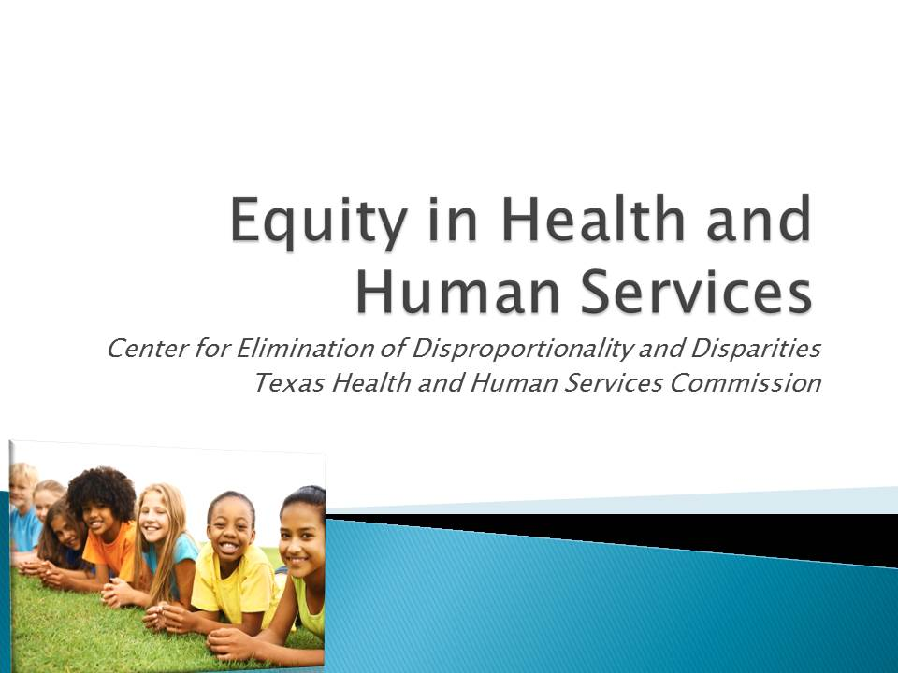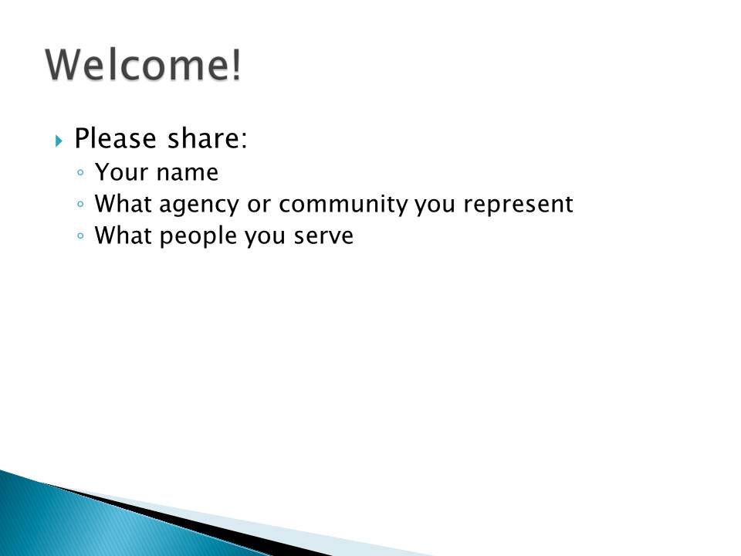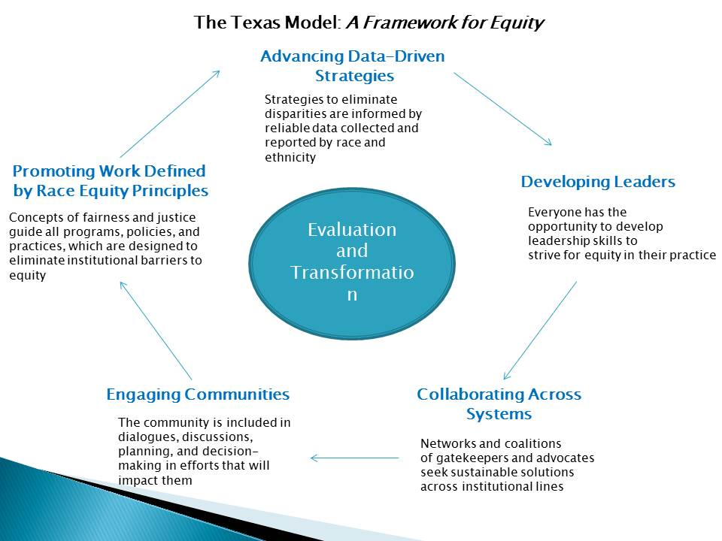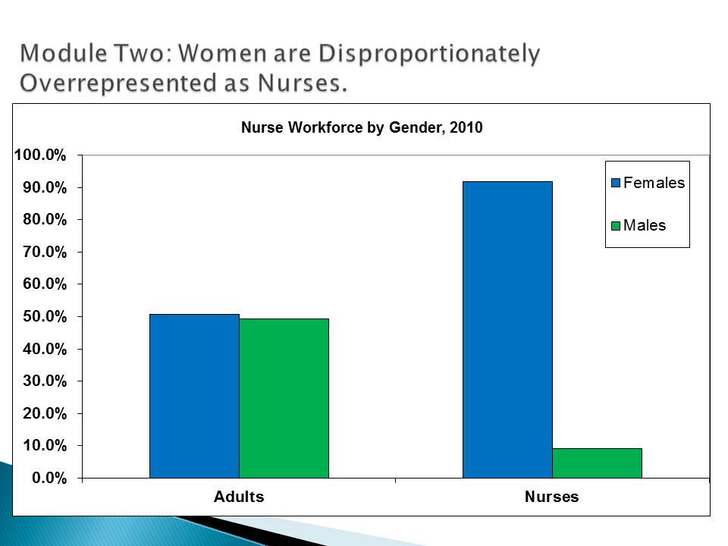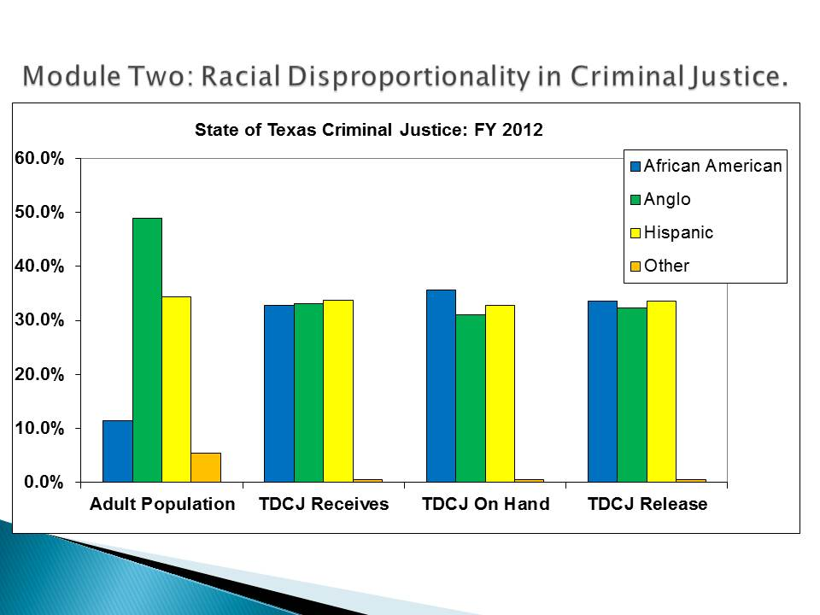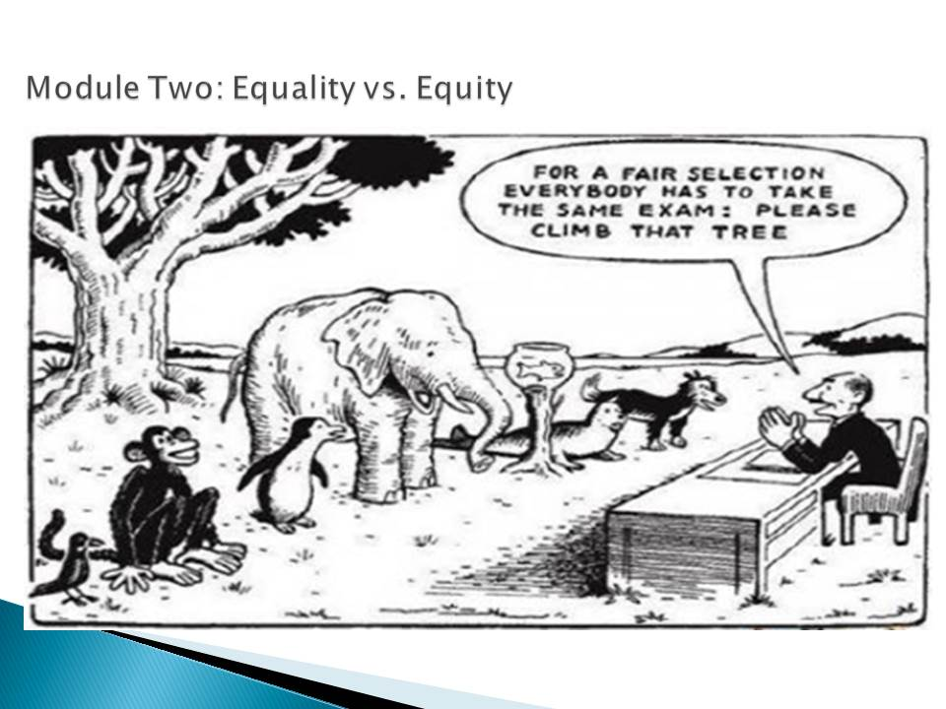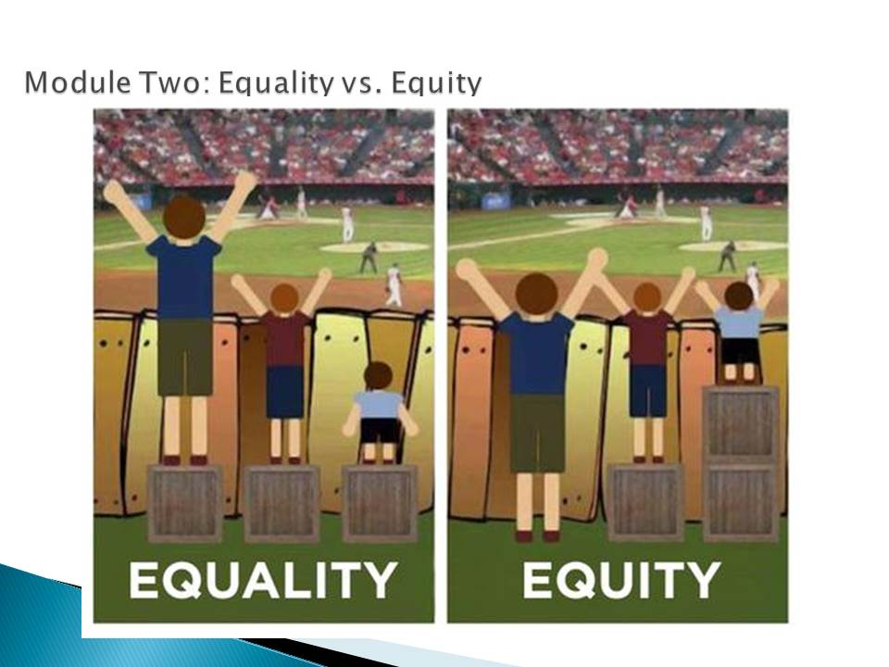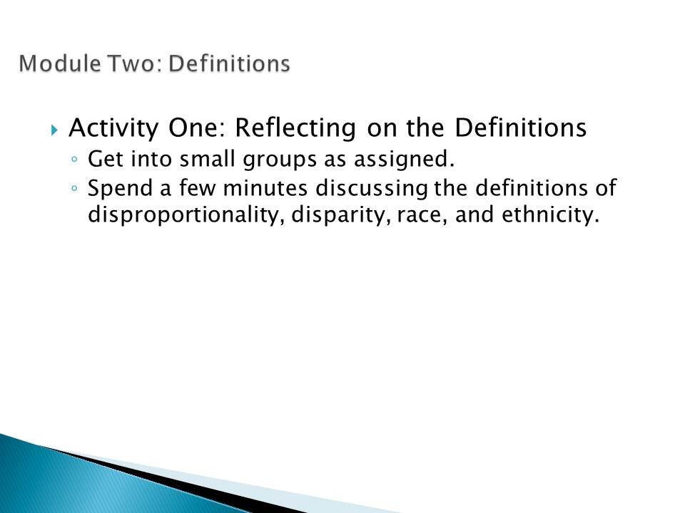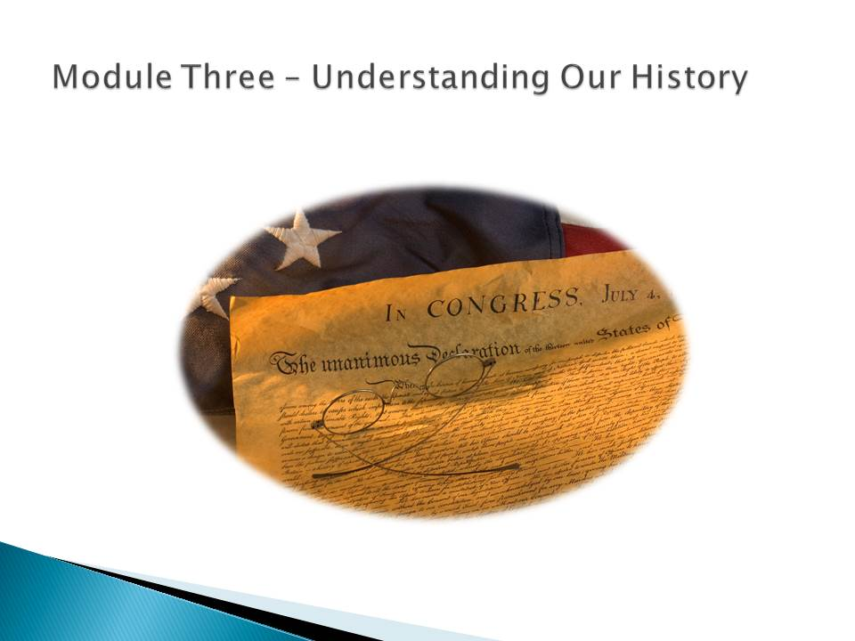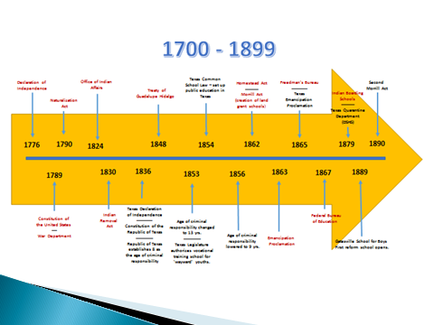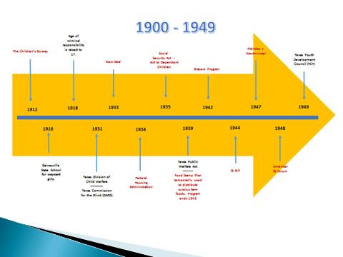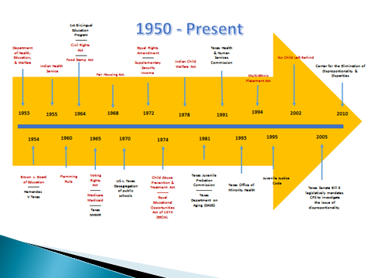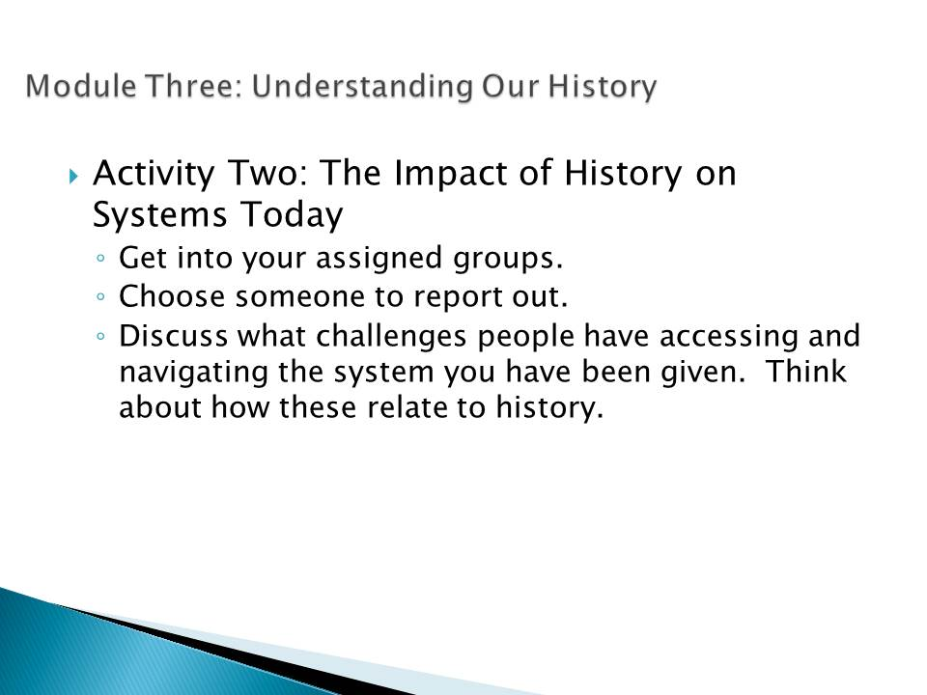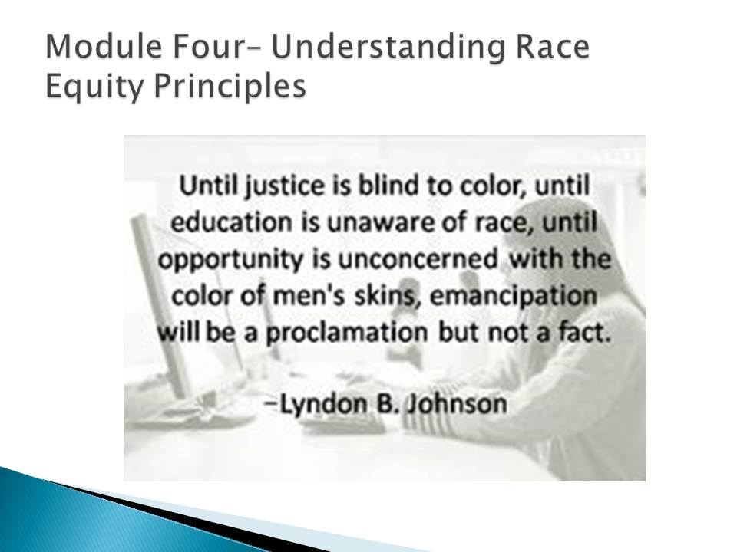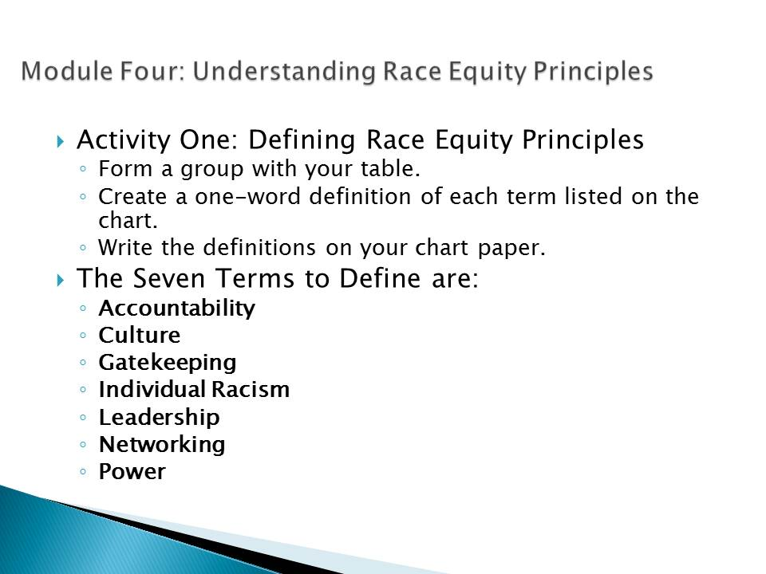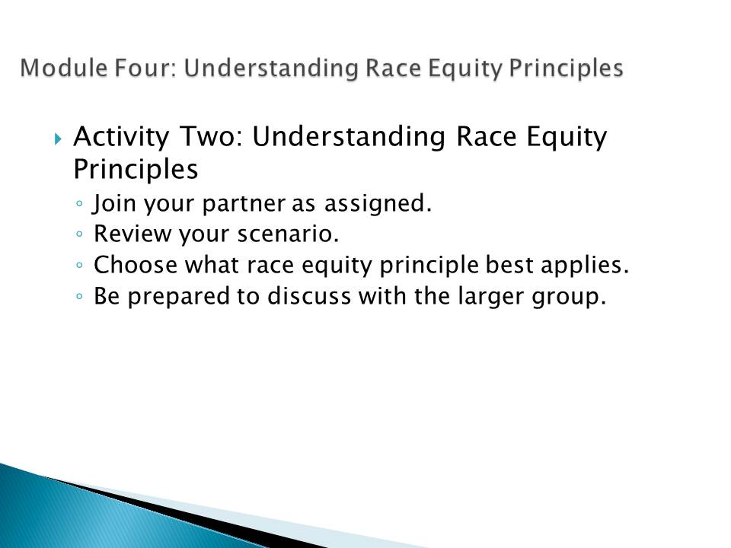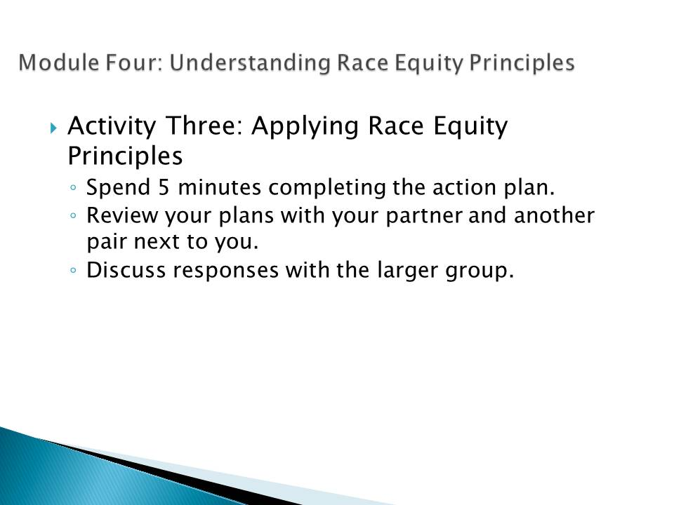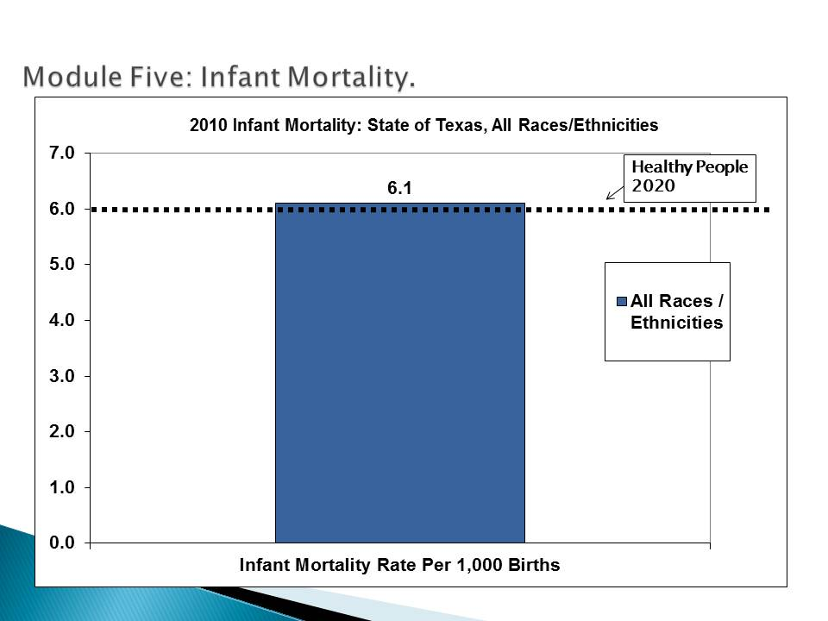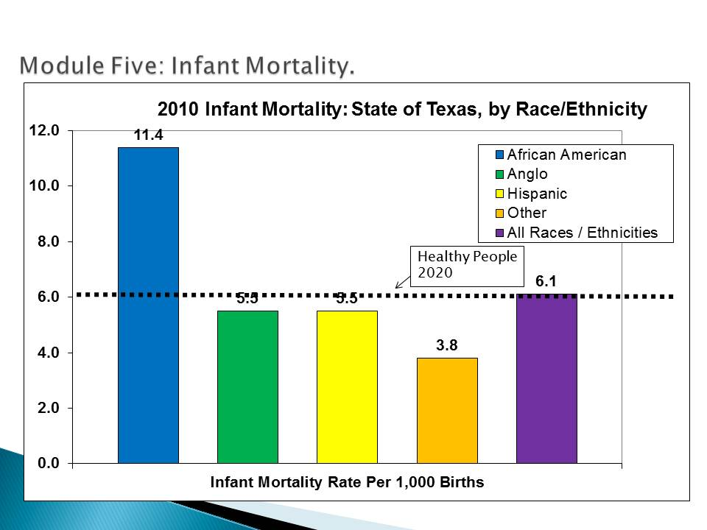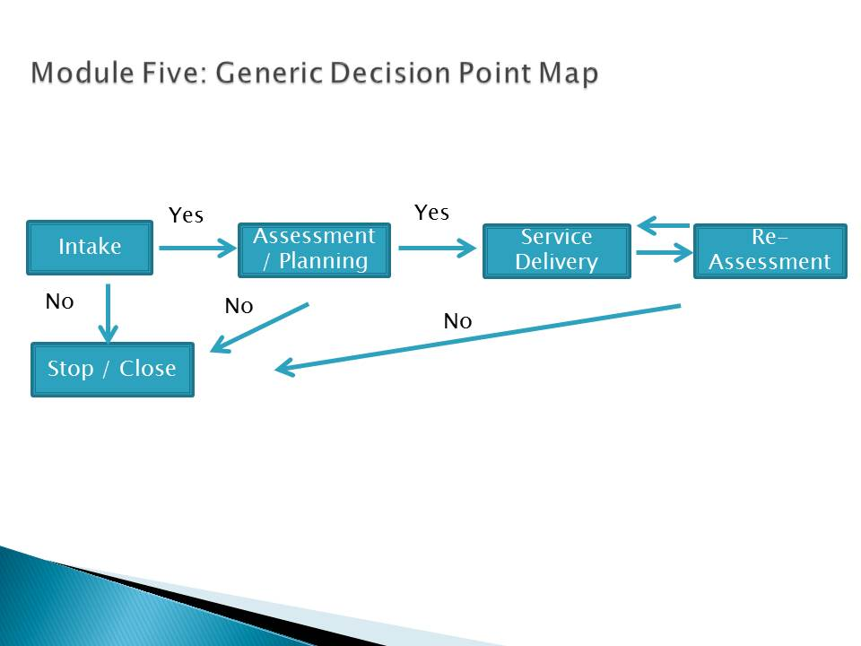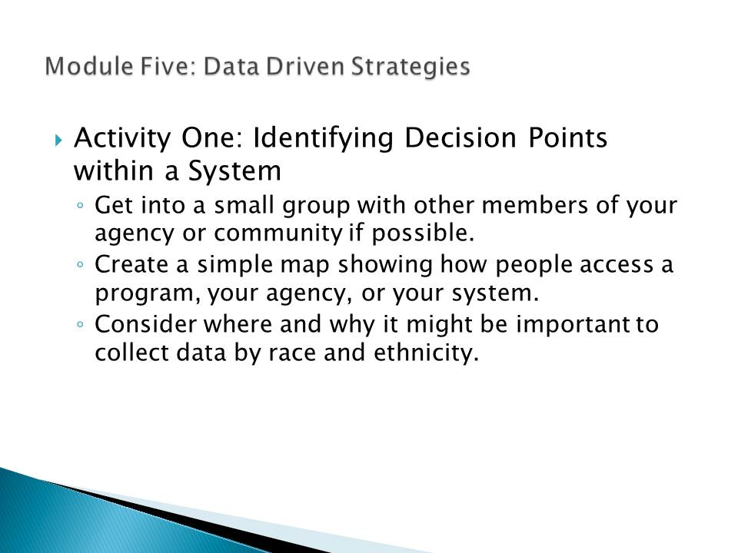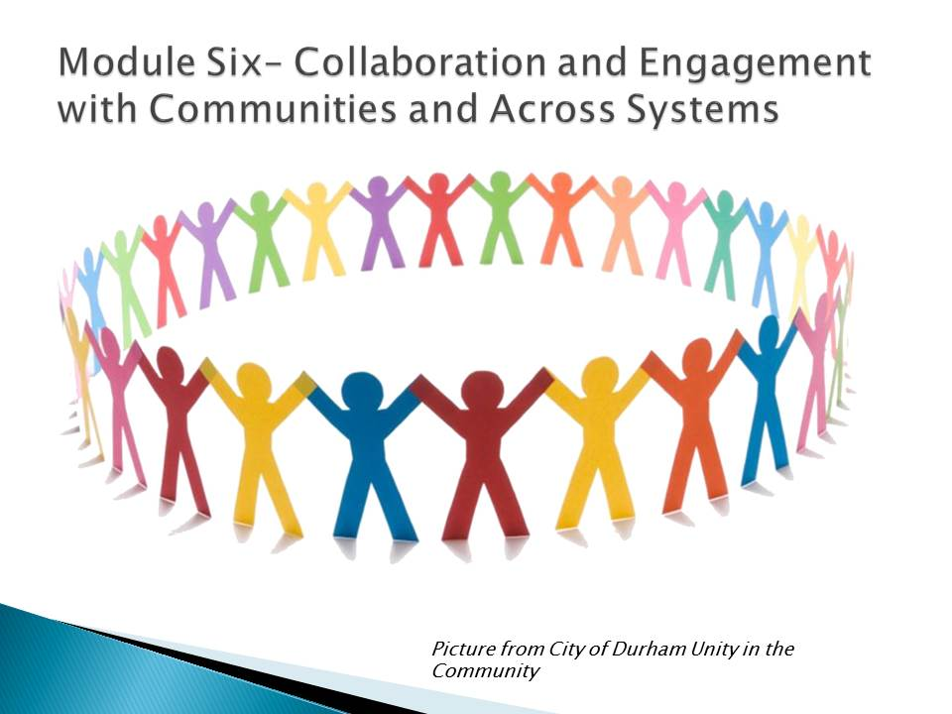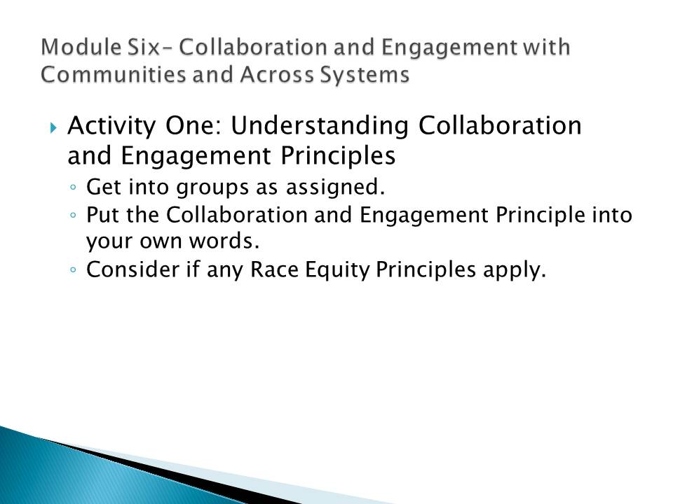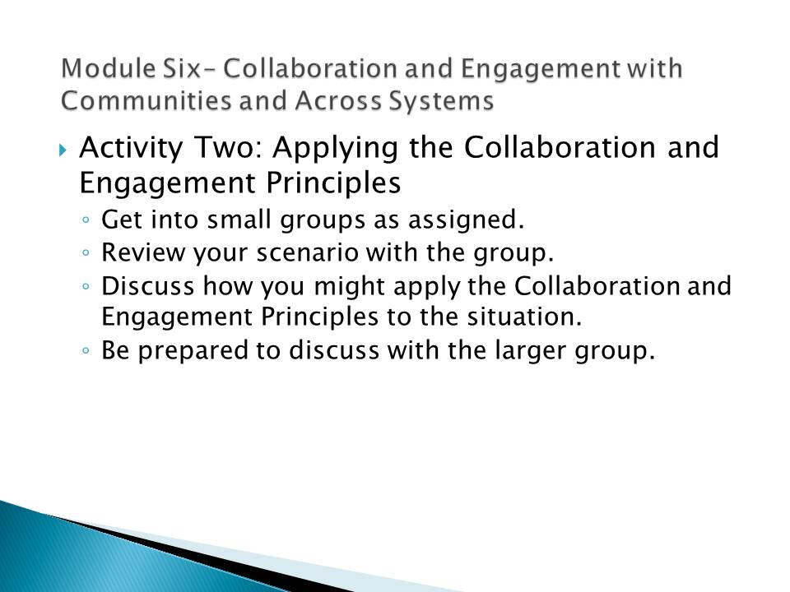

- The Texas Model: A Framework for Equity

